

Dog Walker
Training Packet
Updated: 2026
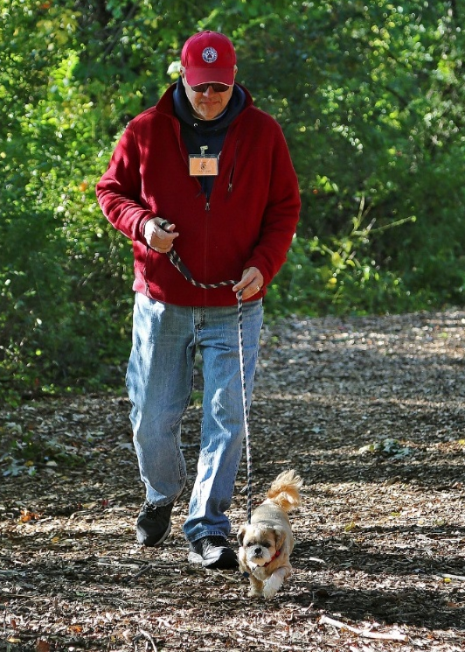

Welcome:
Thank you for volunteering your time to help the dogs during their stay at the Connecticut Humane Society.

Objective:
Daily walks provide the dogs with necessary exercise and mental stimulation. All dogs are walked at least twice a day for a minimum of 20 minutes per walk. Ideally, each dog should also receive some play time in the fenced-in pen every day unless they are restricted due to a medical condition.
Volunteer Supplies:
Slip leads/Harnesses
Dogs are walked using their assigned slip lead or harness. Slip leads are special leashes that tighten to prevent the dog from becoming loose. Once the leash is around their neck, slide the leather stopper in place to prevent the lead from loosening.

Some dogs have been assigned a harness and should not be walked on a slip lead. Always check harnesses for proper fit as buckles can loosen over time.

Poop bags/Treat/Treat Pouches
Carry poop bags and always pick up after the dogs. Treats are used to reward good behavior. Break treats into small pieces (about the size of a pea) to prevent over-feeding. Treat pouches are available for volunteer use.
Walkie Talkies
Some CHS locations require the use of walkie talkies for safety. Walkie talkies should be kept on during your shift. When returning the walkie talkie to the charging station, turn it off so it will recharge for the next user.

General Information:
Once you’ve gathered your supplies, check the dog walking board to see which dogs need walks and read any notes. Dog walkers may walk one dog at a time. If two dogs are being housed together in a kennel, two dog walkers may take them on a walk together.

Signs:
Always familiarize yourself with the dog’s cover sheet and posted signs before taking them out and make sure you know their name and assigned color code. Pay attention to special instructions about their health or behavior and any restrictions.
Prescription (Rx) Diets
If a dog is being fed a prescription diet, they may have a food allergy or are being treated for an illness or medical condition. Do not feed these dogs treats. Even a tiny treat can cause them medical problems such as an allergic reaction. Instead, their prescription kibble may be used as a reward.
Short Walks Only/No Pen Time
These dogs may be recovering from surgery and failure to heed the warning may result in injury to the dog.
No Hard Toys/Treats
These dogs may have dental issues. Feed soft treats only.
Behavior Issues
Known behavior issues will be circled on the cover sheets. Volunteers should familiarize themselves with the information in the troubleshooting section of this document for information about handling common behavior issues.
Color Coding:
Behavior Evaluations
All new dogs over 6 months old will be marked “staff only” and must have a behavior evaluation before volunteers are permitted to walk them. Once evaluated, they will be given a color code. Always double check the dog’s color code as it may change from day to day.
“Mellow Yellow” Dogs are generally calm, friendly, rarely pull on the leash or jump and are not reactive around other dogs.

“Peppy Purple” Dogs have minor behavior issues such as pulling on the leash, jumping or barking excitedly when they see other dogs. New volunteer dog walkers will be trained to start at the purple level.
Orange Dogs have more serious behavioral issues such as aggression towards other dogs or the tendency to become overstimulated. They may also be excessively fearful or undersocialized.

Staff Only Dogs (Blue)
Dogs marked staff-only may be under quarantine for biting or be off-limits to volunteers due to a medical or behavioral issue. They may be aggressive towards people, have a history of fighting with other dogs or may be sick or injured.
Volunteers must not handle Staff Only dogs or open their kennel for any reason.

Green puppies are under 4 months old and are too young to be walked outside because they are not fully vaccinated. Dog walkers can interact with these puppies in an empty adoption room at the end of their shift, once all of the healthy adult dogs have been walked. Be careful not to get bitten- they have very sharp teeth! Use toys to keep their mouth engaged.

Asking a Dog to Sit:
With a treat in your hand, simply raise your hand from your side up to your waist. If the dog knows how to sit, they will likely respond to your hand signal. Immediately say “yes” and feed them a treat once they sit. If they do not respond, they may not have learned it yet. Never force a dog to sit by pushing on their rear end.

Safety 101:
- Never stare directly at a dog.
- Never interact with a dog if you are feeling nervous or afraid.
- Watch and listen for signs of fear and aggression. Growling is a sign to stop what you are doing and give the dog space. Immediately notify a manager if the dog you are interacting with growls at you.
- Never approach a dog that is eating.
- Never enter a dog’s kennel- lure them to you instead.
- Know your limits- don’t walk a dog you can’t physically handle.
- Stay out of the dog’s face- no kissing, hugging or bending over the dog.
- Never sit or lie down on the ground with a dog- kneel with one knee up.
- Do not use your cell phone to call, text, surf the internet or listen to music while handling dogs.

Removing Dogs from the Kennel:
- Prepare your slip lead so you can easily slip it over the dog’s head.
- Be aware of your surroundings- wait until other dogs are secure before opening the kennel door.
- Open the kennel door when the dog is sitting or standing calmly.
- Prop open the door, using your foot as a stopper to prevent it from swinging open.
- Slide your slip lead over the dog’s head when they come to you.
- Tighten the leash then move the stopper into place to prevent the leash from loosening.
- If the dog is walked on a harness, remove them from the kennel on a slip lead and put the harness on in the designated space.
- If the dog rushes out past you, do not try to grab them by their head or fur. Instead, lasso them with your slip lead or get a staff member for help.
Walking a Dog Through the Kennel:
Keep your dog under control and on a short leash while inside the building. Walk briskly past the kennels to avoid the dogs fighting through the bars. Every time you reach a doorway, pause and check to make sure there aren’t any dogs on the other side of the door.
Leash Hold:
Hold the leash with two hands. Do not wrap the leash around your wrist. This will prevent an injured wrist if the dog pulls or jerks the leash. If the dog is hard to manage, bring your hands into your torso for extra stability.

Walking Procedures:
Dogs are walked in designated areas. Some areas are for healthy dogs and other areas are for sick dogs. It is important that you walk dogs in the proper areas to prevent the spread of contagious illnesses and diseases. All dogs must stay on CHS property during their walks.

Keep the dogs outside for at least 20 minutes. We only shorten walks during extreme weather conditions.

Pick up after the dogs and pay attention to stool consistency. Fecal scores should be recorded on the dog’s daily chart. If the stool is a #7 (diarrhea), give your poop bag to a staff member so they can get a fecal sample.

Never allow customers to interact with a dog you are walking. If approached by a customer, direct them to the front desk for assistance.

All dogs should get a little time to run around in the fenced-in pen each day unless they have a medical restriction. Only one dog is allowed in the pen at a time. Always make sure the gate latches behind you so the dog can’t get loose. Let their leash drag on the ground. This will be handy for catching the dog if needed. Pay attention to your dog- make sure they are not trying to jump over the fence or are digging under it. Dogs who are a Flight Risk must have a long-line attached to their collar when they are loose in the pen.

Loose Dogs:
- Make sure equipment (leashes and harnesses) are on and fitted properly.
- Always check kennel latches, gates and doors to make sure they are closed properly.
- If a dog becomes loose, yell or use your walkie talkie to radio for help.
- Try kneeling down and calling the dog to you. Try luring them with treats.
- Run away from the dog while calling them to you.
- Never grab a loose dog by their head or fur. Instead, loop them with a slip lead.

Returning a Dog to the Kennel:
- Wait until other dogs in the kennel are secure before putting your dog back in the kennel and make sure they are going into the proper kennel.
- Without entering the kennel, lead the dog back inside.
- If the dog resists, try tossing a treat into the kennel. You can have them follow you in, but quickly exit so you aren’t remaining inside with them.
- Stand at the threshold and close the door so it is only slightly ajar, using your foot as a stopper to prevent the door from swinging open.
- Slide the slip lead off over the dog’s head then close the door.
- Double check that the kennel latch has closed properly so the dog cannot become loose.
- Wash or sanitize your hands then sign your initials on the white board to indicate the dog has been walked.
- Mark the dog’s daily chart. Follow the instructions for recording whether they urinated or defecated. If they defecated, use the fecal scoring system to assign them a number 1 through 7. You can find the scoring chart hanging in the kennel. Assign the dog a Behavior Grade.
- If you have any concerns about the dog, notify a staff member.

Isolation Kennel:
Volunteers may walk dogs in the Isolation Kennel (ISO) once all the healthy dogs have been walked. Volunteers who would like to interact with healthy puppies must do so before moving on to the Isolation kennel.

Dogs in the Isolation kennel are usually being treated for “Kennel Cough” which is highly contagious to other dogs, so the ISO kennel should always be the last stop and volunteers should not re-enter any healthy kennels or touch any other dogs after walking sick dogs. Kennel Cough symptoms include a persistent cough, sneezing, runny nose, eye discharge, lack of appetite and decrease in energy.
Volunteers will be shown where to walk the sick dogs and must follow the guidelines on the posted yellow door sign regarding the use of gowns, gloves and foot baths.
Preventing Dog Fights:
- Walk one dog at a time.
- Keep at least 15 ft. from other dogs.
- Double check that slip leads and harnesses are on and fitted properly to prevent loose dogs.
- Be sure to securely latch the doors when returning dogs to their kennels.
Handling Dog Fights:
- Stay calm
- Use steady pressure on the leash to pull them apart
- Use your walkie talkie or yell for help
- Dogs can be sprayed with a hose or dog repellent spray
- Use a heavy object (ex. the lid of a garbage can) as a divider between the dogs to break them apart

Safety Notes:
- Never attempt to pull the dogs off of each other using your hands. This will likely result in a bite.
- Never touch a dog after a fight. Walk them away from the other dog once separated, and allow them to calm down.

Reporting an Incident:
Immediately report any bites or incidents to the manager-on-duty and complete an incident report.

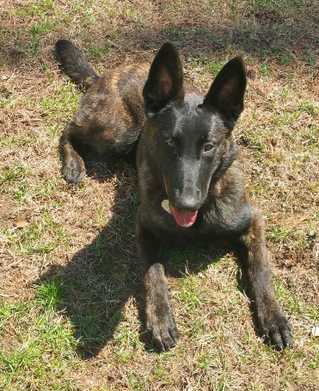
Canine Body Language:
HAPPY/RELAXED
- Generally calm demeanor
- Tail is wagging or lying neutrally
- Mouth may be slightly open or “smiling”
- Ears are in a relaxed state
- Soft eyes
- Willing to approach

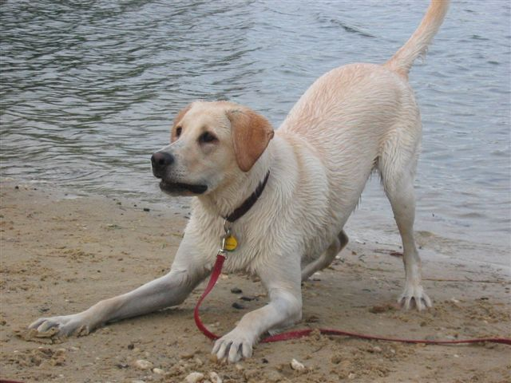
PLAYFUL

• Upper body is dipped down in a “play bow”
• Tail is wagging or straight up
• Arms are splayed out
• May be barking excitedly
• Bouncy movements

FEARFUL/NERVOUS
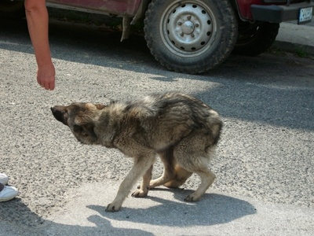
- Hesitant to approach
- Tail is tucked under their body or low tail wag
- Lowered stance (cowering , crouched, or lying down)
- May be trembling or panting
- Ears are pulled back against the head
- Avoiding eye contact
- Yawning
- May be licking their lips
- May be growling
- No interest in food
- May lift one paw
- Hackles may be up (raised fur on back/shoulders)

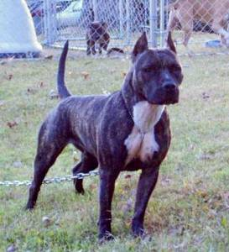
ABOUT TO AGGRESS
- Rigid stance- very still
- Intense stare
- Tightly closed mouth
- Tail is straight up in the air or directly behind
- Body weight moved forward onto front legs
- May be growling
- Furrowed brow
- Whale eye (whites of the eyes are showing)

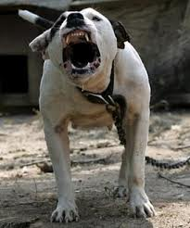
AGGRESSION
- May be growling or deep bark
- Teeth are showing
- Intense stare
- Tail is straight up in the air or directly behind
- Ears are pulled back or perked up
- Hackles are up (raised fur on back/shoulders)
- Body weight moved forward onto front legs or lunging

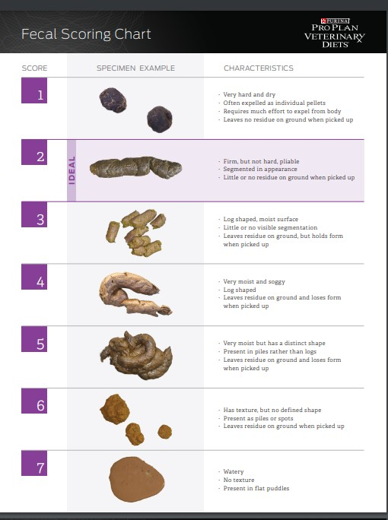
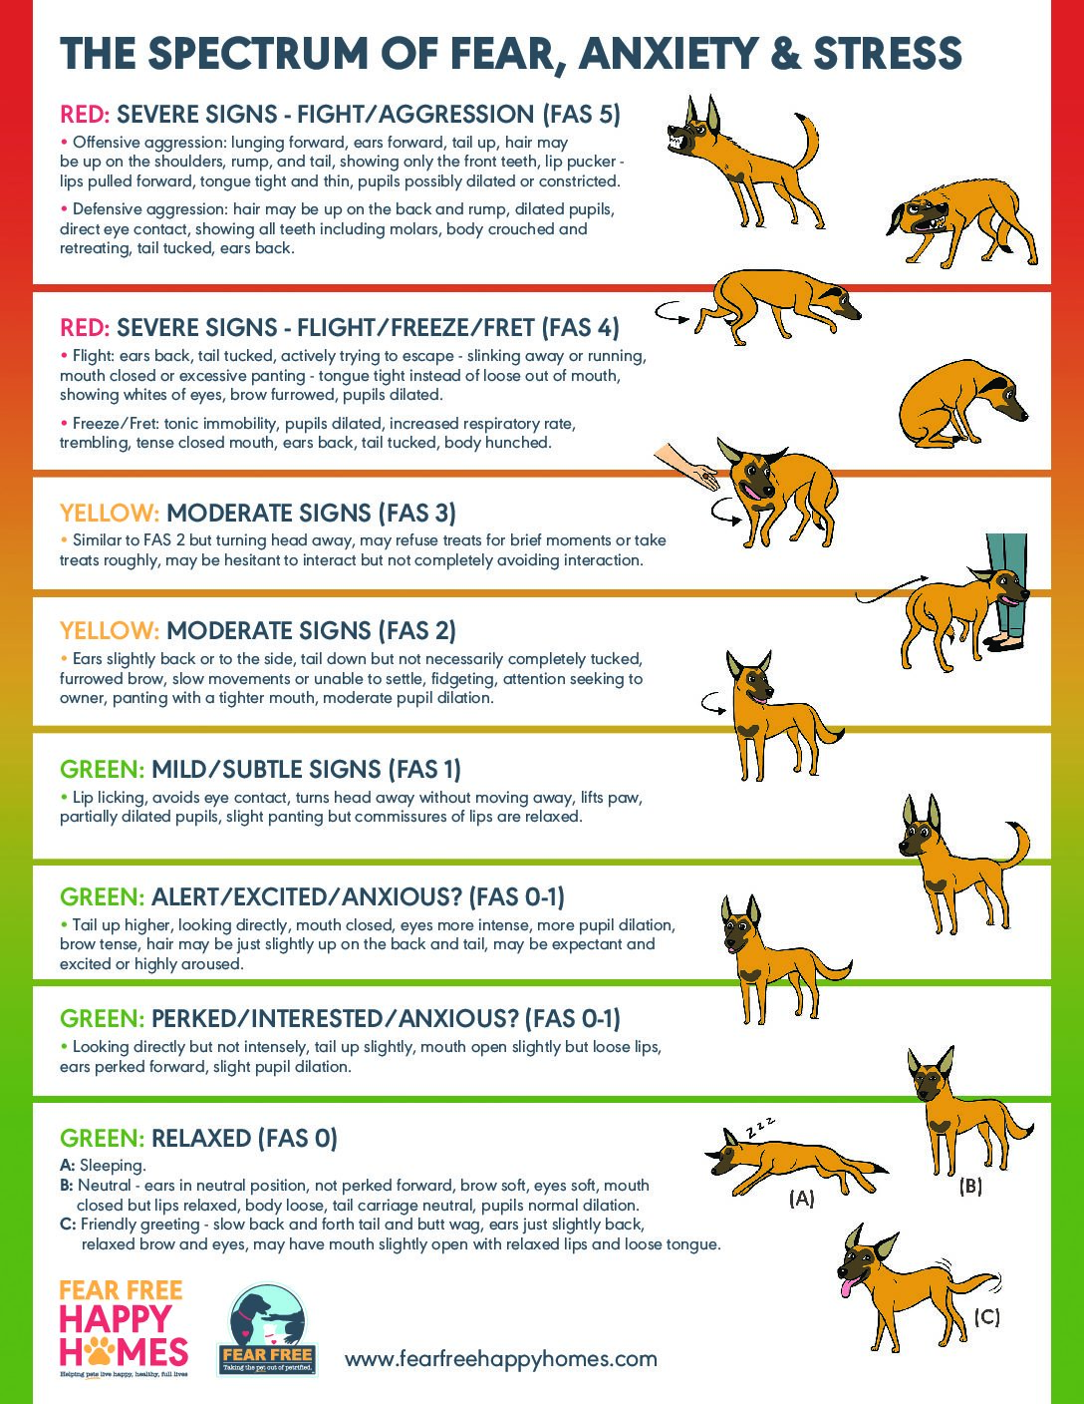
TROUBLESHOOTING COMMONG BEHAVIOR ISSUES:
PULLS ON LEASH- The dog pulls on the leash and needs to learn how to walk loosely on the leash.
- When you feel tension on the leash immediately stop walking.
- Lure the dog back to you by using a treat or calling their name. Once there is some slack in the leash, continue walking forward.
- You can also feed the dog treats or toss them on the ground as you walk so the dog stays close. Eventually slow the flow of treats from continuous to every so often.
- If the dog is not interested in treats, change direction whenever the leash goes taught so that the dog learns to follow you. The reward is moving forward.
JUMPING- Dogs jump on people because they are seeking attention.
- When the dog jumps, do not scold them or push them off. Any form of attention (even negative attention) is a form of reinforcement.
- Instead, turn your back towards them and don’t say anything else until they return to the ground.
- Once all four paws are on the ground, turn around and reward them with attention and praise.
- If the dog knows “sit,” ask them to sit then reward them with attention and praise. Repeat this throughout the walk so they learn that sitting gets attention and jumping does not.
- While walking, do not face the dog. Look in the direction you want to move in and walk firmly.
- If the dog is jumping excessively, you can stand on their leash to prevent them from jumping until they calm down.

REACTIVITY- Barking, lunging or growling at other dogs or simuli.
- Plan your route through the kennel to decrease the number of dogs they have to walk past.
- Walk briskly past kennels with dogs in them and use high value treats to keep the dog focused on you.
- Do not put yourself between the dog you are walking and the dogs in the kennels- this is to prevent misdirected aggression.
- Keep far away from other dogs on walks.
- If the dog sees another dog and starts to stare, lunge or bark, say “Let’s Go!” and move in the opposite direction.
- Use high value treats to teach the dog to sit and focus on you while in the proximity of other dogs.

OVER AROUSAL- Over-arousal is characterized by jumping, grabbing hands/body parts with their mouth, biting at clothing and/or biting the leash. Over arousal is common in dogs that are kenneled most of the day with limited exercise.
- Provide the dog with plenty of exercise but avoid playing roughly.
- Practice obedience commands.
- While walking, do not face the dog. Look in the direction you want to move in and walk firmly.
- If the dog becomes inappropriate, be boring! Stand still. Cross your arms over your chest to keep them out of the way.
- Ask the dog to perform a more appropriate behavior, such as “sit,” then reward with treats or try distracting them with a toy.

SHY DOG- Shy or fearful dogs may be under-socialized or have difficulty adjusting to new environments. These dogs require extra patience to help them feel comfortable.
- Make sure leashes and harnesses are on and fit properly. Shy dogs may be a flight risk if they get loose.
- Use extra care not to make loud noise when opening and closing kennel doors.
- Turn your body to the side or kneel to appear less threatening when approaching these dogs and avoid direct eye contact.
- If the dog will not come to you to be leashed, lure them with treats. Toss a treat to them. If they eat it, toss one a little closer. Continue this until they get close enough to be leashed.
- If you are unable to leash them, ask a staff member for assistance.
- Never drag a shy dog with their leash. This will only create more fear.
- If they show signs of fear on your walk (cowering or trying to get away from something) move away from that object.
- Be careful! Shy dogs may bite if they are scared. Only pet them if they initiate the interaction by coming to you.
FLIGHT RISK- The dog is prone to run away from- rather than toward- people if frightened. They also tend to startle more easily than the average dog.
- Take care not to startle the dog. Open and close kennel doors softly.
- Move slowly, talk quietly, and do not face the dog head-on.
- Crouch when removing and returning the dog from the kennel.
- Avoid noisy/busy areas.
- Make sure harnesses are on and fitted properly.
- Always keep two hands on the leash and keep a tight grip to prevent the dog from getting loose if startled.
- Attach a long line to their leash when they are in the play yard and pay close attention that they are not attempting to jump over or dig under the fence.
HOW TO PUT ON A FREEDOM HARNESS
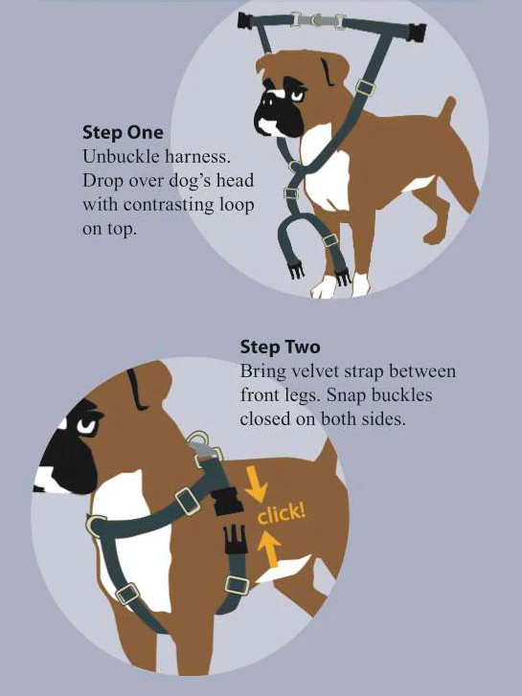

HOW TO PUT ON AN EASY WALK HARNESS
1.Buckle the chest strap with the silver ring to the matching strap, then place over the dog’s head with the silver leash attachment ring on their chest.
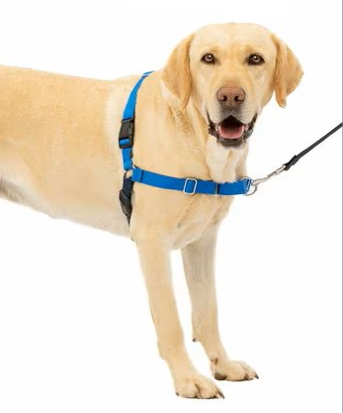

Silver leash attachment ring

2.Place the belly strap under their armpits then buckle it.

