

Cat Handling Guidelines

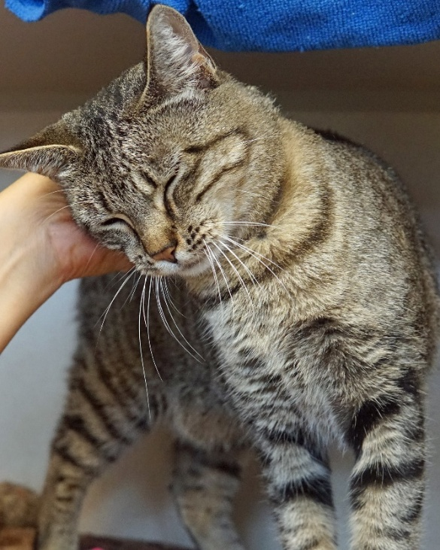

Updated 2026

General Information:
Always familiarize yourself with the cat’s cover sheet before interacting with them. Pay close attention to posted signs for special instructions about their health or behavior.

Staff Only
Cats marked “Staff Only” may be off-limits to volunteers due to a medical or behavioral issue, or may be under quarantine for biting. They may be aggressive, fearful or contagious. Volunteers must not open their cage or enter their enclosure for any reason. This is for safety reasons and to prevent the spread of disease.

Fur Squad
Cats marked “Fur Squad” may be shy or fearful or have a tendency to become overly aroused. They may be under-socialized or may have come from a hoarding situation. They have the potential to bite or scratch. They may only be handled by staff or trained “Fur Squad” volunteers. Volunteers who have not received Fur Squad clearance should not open their cage or enter their enclosure for any reason.
No Roaming
Cats marked “no roaming” are not allowed out of their enclosure to roam the room. Most commonly, this is because they are recovering from surgery, but it could also be due to a behavior issue. Cats marked “No Roaming” may be held or may rest on your lap but should not be allowed to roam or run around.
Rabies Vaccinated Staff Only
When a dog or cat arrives at the shelter with a wound of unknown origin, state law requires the pet to be quarantined for four months for a rabies observation period. Cats being quarantined for this reason are off-limits to volunteers and only rabies-vaccinated staff will be allowed to interact with them.

Rx Diet
Prescription diets are commonly used in cats with issues such as vomiting or diarrhea, allergies, or for weight loss or urinary issues. Cats who are on special diets should not be given treats.

FIV+
Cats marked FIV+ have the Feline Immunodeficiency Virus. FIV is not contagious to humans but can be spread to other cats through direct physical contact such as biting or mating. If a cat is FIV+ they cannot be allowed out with other cats unless they are residing in the same cage with another cat.

URI Recovery
Cats recovering from URI (Upper Respiratory Infection) should no longer be contagious, but to be safe, these cats should not be allowed out of their cages to roam and should be handled after all of the healthy cats have had some interaction.

Volunteer Responsibilities:
- Make sure cats have fresh water, a clean litter box, blankets and toys.
- Spot-clean as needed.
- Keep the room clean and tidy; put supplies back in their appropriate space, keep counters clean, put dirty laundry in the bin, sweep the floors as needed.
- Disinfect cages (if trained).

Behavior Grading Criteria:
After each cat interaction, give the cat a grade based on the below criteria. Report the grade on the Feline Grading Observation Sheet.
A: Actively solicits attention, easy to handle, purring, kneading, head butting, relaxed body postures.
B: Enjoys interaction but does not solicit/initiate.
C: Does not resist interaction but does not solicit. Body posture may show signs of stress, but does not react
offensively.
D: Vocal threats (hissing/growling), defensive posturing, may react aggressively to being handled or touched. Redirects aggression on humans if upset by other animals.
F: Biting, scratching, striking (intent to harm).

Aggressive behavior such as hissing, swatting or attempting to bite, should be reported to a staff member verbally right away in addition to being recorded on the grading sheet.

Fecal Scoring:
When scooping litter boxes, assign the cat a fecal score (1-7) based on the fecal scoring system chart hanging in each cat holding room. This information is extremely important to our medical staff so they can assess the health of each cat. If diarrhea is noticed, please do not discard it and alert a staff member so they can take a fecal sample for testing if needed.

Feeding:
The cats are fed twice daily. Volunteers may only assist with feedings if trained and assigned to do so.

Disease Prevention:
Some animals who come to CHS are sick and potentially contagious.

To prevent the transmission of contagious illnesses throughout the building:
- Pay attention to color-coded door signs and follow instructions.
- Only enter rooms you have been assigned to work in.
- Wash hands after handling every cat, but before handling their paperwork.
- Return cats to the same cage they came out of.
- Do not allow sick cats out to roam or allow them to play with shared toys such as wands.
- Tell a staff member if you have a medical concern about an animal.
- Follow the guidelines in the Volunteer Handbook for preventing the transmission of contagious illnesses to your pets at home.
- Interact with cats in this order:
1. Healthy kittens before adults.
2. Healthy adult cats
3. Animals recovering from an illness

Working with Sick Cats:
Some volunteers may receive training to work with cats who are currently being treated for an Upper Respiratory Infection (URI). Cats with URI are highly contagious to other cats. To limit the spread of URI, volunteers must follow the protocols posted on the colored room sign. Gloves, gowns and disinfecting foot mats are required when working with the cats in the URI room. Volunteers must not enter any animal holding areas or handle any other cats in the building after interacting with cats in the URI room.

Safety 101:
- Keep your eyes on the cat you are interacting with.
- Pay attention and look for subtle changes in their body language.
- Stop handling the animal if they give signs that they don’t want to be handled, such as growling or hissing or other cues that they are uncomfortable.
- Don’t be too loud or animated.
- Silence your cell phone.
- Never use your cell phone while handling a cat.
- If you are unsure about an animal, check with a staff member to make sure it is safe to interact with them.
- Never attempt to cut a cat’s nails or trim mats. Alert a staff member if a cat needs to be groomed.
- Ask a staff member for assistance if you need help getting a cat back in their cage.

Preventing Cat Fights:
- Only one cat is allowed out for roaming at a time.
- Communicate with your fellow volunteers before letting a cat out to roam.
- When returning cats to their cage, make sure the door latches properly so they cannot get loose.
Never use your hands to break up a cat fight. Spray fighting cats with water from the bottle or a hose or get a staff member for assistance. Do not touch the cats immediately after a fight. Give them plenty of time to calm down before you attempt to move them.

Reporting an Incident:
Report any bites or incidents to the manager-on-duty immediately and complete an incident report. If a bite breaks skin, the cat must be quarantined for 10 days in accordance to state law for a rabies observation period.
How to Approach a Cat:
- A soft gaze and slow blinks communicates your good intentions.
- Offer a closed fist for the cat to sniff.
- Wait for the cat to head-bump or rub against you.
- Don’t force an interaction.
How to Win at Petting:
- Start with the head and face.
- Stroke the cat from the forehead to the tail.
- Keep strokes gentle and slow.
- Listen for purring!
- Many cats over age 9 have arthritis. Be gentle on their hips and back end.
Safety Tips:

Where to Pet a Cat:
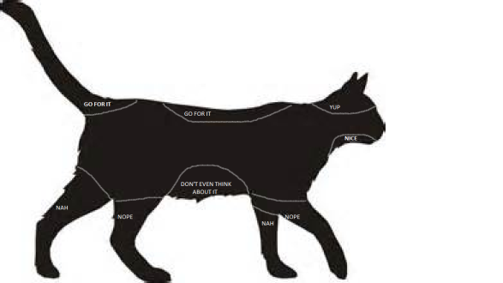

Correct Way to Hold a Cat:
- Support the cat’s weight.
- Hold the cat against your body for added support.
- The cat’s face should not be near your face.

Feline Body Language:
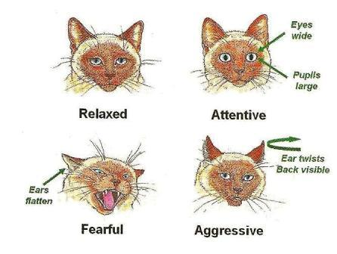
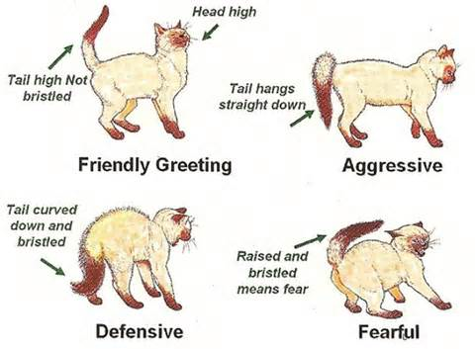
Warning Signs
- Hissing
- Growling
- Ears flat (airplane ears)
- Failure to approach

Signs that a Cat is Friendly
- Approaches you
- Tail held high
- Head-bumps you
- Relaxed face
- Rubs against you

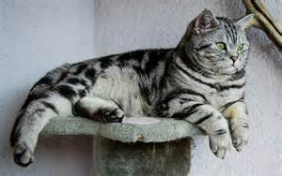
RELAXED

• “Soft” eyes
- Relaxed face
- Lying on their side
- Purring
- Kneading their paws

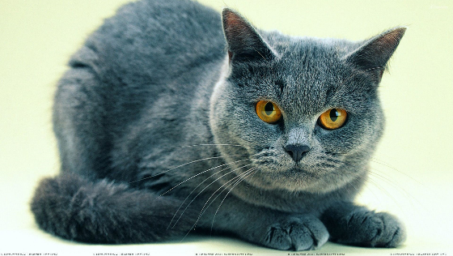
TENSE/FEARFUL
- Body tucked in
- Tail held close to the body
- Ears may be flattened
  - May be cowering at the back of their enclosure or hiding

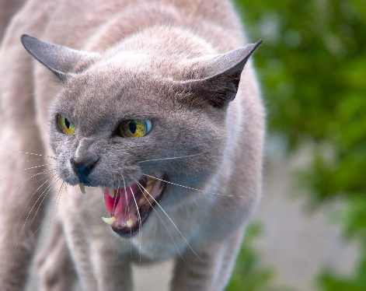
DEFENSIVE
• Bristled hair
• Arched back
• Flattened ears
• Tail is puffed up
• May be thrashing tail
• May be hissing or spitting

DEFENSIVE THREAT
- Ears pulled back
- Head and neck tight against the body
- Teeth displayed
- May be rolled onto the side to expose claws


AROUSED/OVERSTIMULATED
- Enlarged pupils
- Wide-eyed stare
- Tense body
- Swishing tail
- Fur rippling on the back or sides

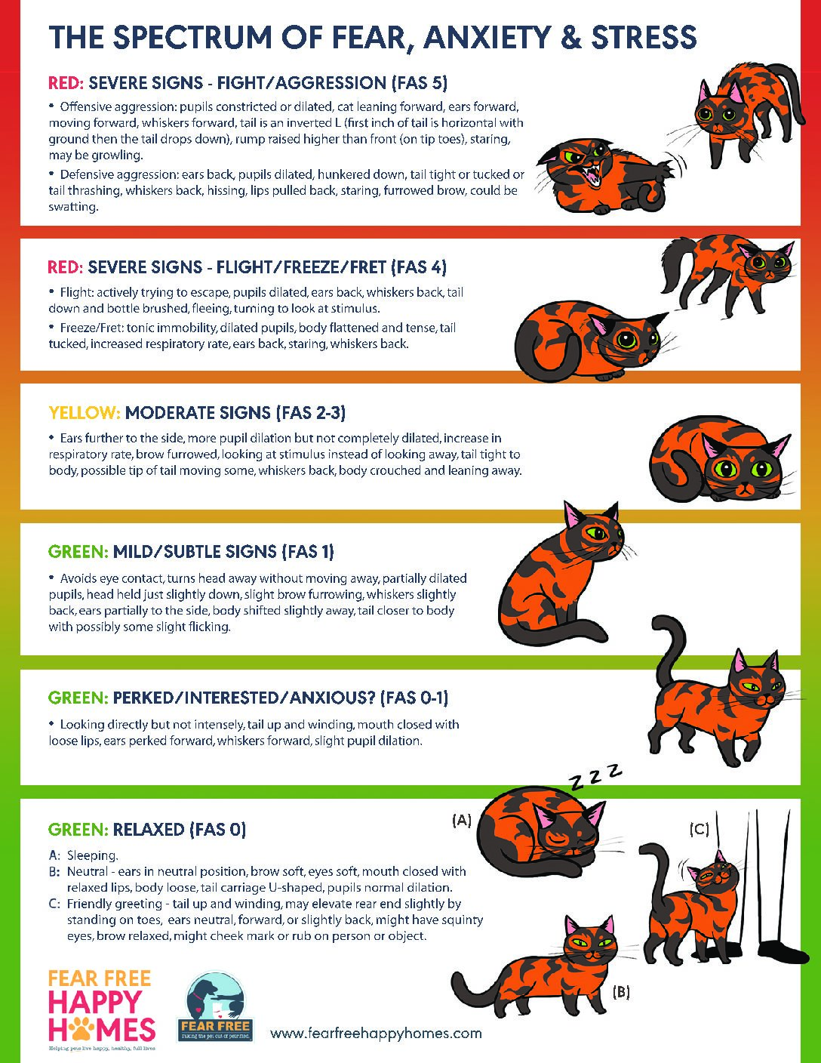
COMMON BEHAVIOR ISSUES
FEARFUL/ANXIOUS/STRESSED/SHY
Some cats may be under-socialized or have difficulty adjusting to the shelter environment. These cats require extra patience to help them feel comfortable. These cats should be given a place to hide in their enclosure. These cats may be marked Staff Only or Fur Squad only. They are more likely to bite if they feel nervous or threatened.
- Go slow and talk in a quiet voice when interacting with these cats.
- Use extra care not to make loud noise when opening and closing enclosure doors.
- Be careful! These cats are more likely to bite. Only pet them if they initiate the interaction by coming to you.
DEPRESSED
Cats can become depressed due to a variety of reasons. Being separated from their family and home can cause depression in addition to stress and illness. Signs of depression include loss of appetite, lack of interest in interacting with people, a lack of energy, change in body language (such as a tucked tail) and poor grooming habits. Feliway sprays, collars or diffusers may be used to help alleviate stress.
- If the cat begins eating during your interaction, stay with them until they finish their food.
LITTER BOX AVOIDANCE (LBA)
If a cat is urinating or defecating outside their box, they will be given a larger enclosure and may be assigned a special type of litter or litter box. LBA may be due to a medical condition or stress. Feliway spray, diffusers or collars may be used to help alleviate stress.
- Follow posted signs to make sure the cat is given the proper litter box and litter type.
- Scoop the litter box after each use and record notes on the LBA log.
- Report any accidents outside of the litter box to a staff member so it can be recorded.

OVERAROUSAL/OVERSTIMULATION
A state of over-arousal can be caused by cat nip, frustration (ex. cat looking out the window at a bird) or during play. Some cats become overstimulate by long petting sessions. Signs of over-arousal/ over-stimulation are dilated pupils, flattened ears, staring at stimuli, a thrashing tail or fur rippling down the back. Cats who are over-aroused may bite.
- Make sure the cat does not have access to cat nip or toys with cat nip in them.
- Keep petting sessions short. Some of these cats prefer hands-off interactions such as playing with wand toys and laser pointers.
- Do not pet the cat immediately after a play session.
- Keep a close eye on the cat to look for signs of over-arousal. End the interaction if signs are noticed.

