**CT Humane Society Enrichment Guidelines   
Updated 2021**

We are so happy to have you as a member of the Enrichment program. Enrichment is a vital part of maintaining the behavioral and emotional health of the animals housed at CHS. This guide will cover some of the basic information you will need to know to do your job, but you will learn much more at your hands-on training.

***Please note that this program does not involve animal handling so Enrichment volunteers are******not permitted to touch or handle the animals during their shift****.   
All animals in our care receive daily interaction, which requires specialized training.*

**What is Enrichment?**Animal Enrichment (also known as behavioral or environmental enrichment) is an animal husbandry principle that seeks to enhance the quality of shelter animal care by providing environmental stimuli necessary for optimal well-being.

If the environment is not enriched and pets are left in empty kennels with little to occupy their minds they can become bored or even depressed. They may stop eating or begin exhibiting repetitive behaviors such as pacing back and forth or chasing their tails. Lack of enrichment can also lead to physical deterioration.

***Why* do Enrichment?**The goals of environmental enrichment are to:

* Improve or maintain an animals’ behavioral and emotional health by allowing species-specific behaviors such as chewing, chasing, foraging or digging.
* Prevent boredom, stress, anxiety and fear through changing stimuli.
* Prevent or reduce the frequency of abnormal or repetitive behaviors such as pacing or spinning in circles.
* Increase the pet’s ability to ability to cope with the stress of shelter living such as loud noises, confinement and close proximity to other animals.

**Enrichment at CHS**CHS prides itself on our efforts to create a variety of enrichment opportunities for the pets. Pets receive enrichment daily from both staff and volunteers, including:

* A variety of toys in their kennels, including toys that encourage species-specific behaviors such as chewing or foraging.
* A variety of special treats throughout the week and special treat-dispensing puzzle toys to engage their minds.
* Equipment such as agility obstacles, kiddie pools, scratching pads, tunnels, ball pits and digging pits to provide a variety of activities for the animals.

Enrichment volunteers work hands-off with the animals to provide mental stimulation in addition to stimulation for each of the five senses:

* Auditory
* Olfactory
* Visual
* Tactile
* Taste

We achieve this through a wide variety of activities each day and the use of special enrichment tools such as feeder toys, laser pointers, scented sprays, sound machines and even TVs and iPads! In fact, we have over 60 different enrichment activities to keep things interesting.

Each enrichment activity has a corresponding how-to sheet with simple instructions for performing each task. Enrichment volunteers will perform a variety of activities each time they come in. You will be shown the location of the how-tos and all of the Enrichment supplies when you come for your hands-on training. It is important to pay close attention to the instructions for each activity.

**Recording Activities**Make sure to log the activities you’ve performed on the Enrichment chart in each room. You will be shown how to do this during your hands-on training.

**Handing Out Toys**Make sure to give appropriately sized toys depending on the size of the pet. Large dogs should not be given small toys that could pose a choking hazard or toys that they could easily rip apart and ingest.

Pay close attention to posted signs such as “durable toys only” or “soft toys only.” Some pets have recently had dental work done and cannot chew on hard toys. If you have any questions about which toys are appropriate, please check with a staff member.

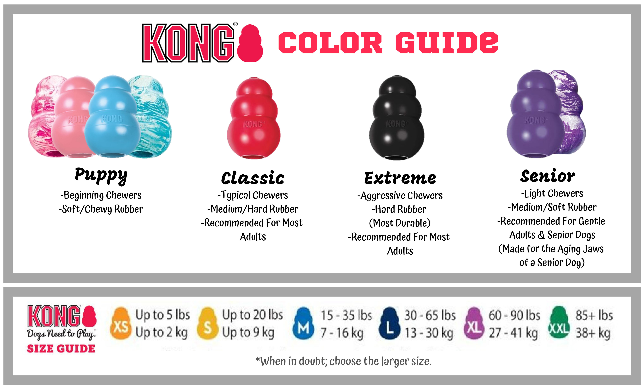

Many large-breed dogs can destroy even tough rubber toys. Black Kongs are extra durable and should be given to strong chewers. The pastel Kongs are made for puppies and are extra soft and the purple Kongs are made from a softer rubber and are perfect for small and medium senior dogs who may have dental issues.

When handing out treat-dispensing toys, make sure to break the treats into small enough pieces so they will come out of the opening.

**Handing Out Treats**

Always pay close attention to posted signs when handing out treats. If a pet is eating a special diet they may not be given treats. Instead, their special food may be given as a treat. This is especially important because some pets are being treated for medical issues such as allergies, diarrhea, vomiting, etc. Feeding food that is not approved by the vet could complicate their medical problems and prolong their treatment and stay in the shelter.

Please do not overfeed the pets! Treats should be given as a small snack, not a full meal. Always break treats into small pieces.

Always pay close attention to product packaging and the approved Edible Items List to make sure the food you are dispensing is appropriate for the species.

**Safety**Always use caution when opening cage and kennel doors to hand out toys and treats. In some cases, treats can be tossed through the kennel bars. Only open the door enough to put in your items and refrain from touching the pet. Be careful that the pet does not become loose. Make sure to fully latch and check the kennel door when you close it.

If a pet is marked “Staff Only” use the divider to close off the pet on one side of the enclosure so you can safely access the enclosure from the opposite side or have a staff member assist you. Be extra careful not to touch pets marked “Staff Only” as they may be undergoing care for a medical or behavioral issue.

**Encouraging Good Manners**You can help the dogs learn good manners when handing out toys and treats. Never reward a dog that is jumping up or barking at you. Wait until they are calm and quiet with all four paws on the floor before giving them a toy or treat.

You can even try asking the dogs to “sit” to earn their reward. Ask the dog to sit while slowly moving your open palm up into the hand signal. If the dog sits, say “yes!” then toss in their reward.

If the dog does not sit right away, DO NOT repeat yourself. Avoid saying “Sit, sit, sit, SIT, SIT!” The dog may not have learned this yet or is not focused.  
  
Instead, say “nope” and turn your back. Turn around again and face the dog. Ask the dog to sit again while giving the hand signal. If the dog still does not sit, say “nope!” then wait until the dog is standing quietly and not jumping up to reward him with his treat.  
  
If the dog still does not settle, take a step back or move away from the kennel and wait for them to calm down, then try again.

**Color-Coded Room Signs**Always check the color-coded room signs before entering a room.   
  
Pets in GREEN rooms are not contagious. Enrichment volunteers should visit with pets in all the green rooms before moving on to the yellow rooms.

Always pay attention to posted signs on kennels and cages. Even though a pet is in a green room, they may have a non-contagious medical issue, such as allergies or dental disease, which may limit the types of toys or treats the can have.

Pets in YELLOW rooms are sick and contagious. Yellow rooms should be the last room you enter on your shift. Only bring the supplies into Yellow rooms that you know you will need. Do not bring any carts into yellow rooms.

Volunteers must step on the mat of disinfectant when entering and exiting the room. Take special care not to touch animals in yellow rooms or their belongings, and wash your hands thoroughly before exiting the room.

Pets in **ORANGE** and **RED** rooms are highly contagious with illnesses that may pose a risk to the other pets. Sometimes they are being treated for something zoonotic, like ringworm, which can also spread to people. Volunteers should never enter an Orange or Red room for any reason.

**Cleaning Up**At the end of your shift, please return all supplies to the appropriate location. Help us keep our storage areas clean and tidy and clean up any messes you made. Leftover canned food can be stored in the refrigerator. Just be sure to mark the date on the can and cover it. If you use up the last of something, please get more from the storage area. And please let us know if we completely run out of something or if something is not working.

**Thank you!**Thank you for taking the time to learn about our Enrichment program. You will be sure to be thanked with lots of smiles, tail wags and purrs. We hope you enjoy your time with the animals!