

**Dog Training &   
Behavior Modification Protocol**

**Objective:**

Help the dogs learn basic manners and use behavior modification techniques to help them overcome their challenges and make them more appealing to potential adopters to shorten their length of stay in the shelter. Although you may only spend a short time with each dog, the cumulative effect of the training team as a whole will have a lasting impact on their well-being.

Training sessions also provide mental stimulation for the dogs which is important for decreasing depression and boredom.

**Dogs in the Program:**

Dogs that are shy/fearful, overly exuberant or reactive towards other dogs or people could most benefit from basic obedience training and behavior modification. These dogs will have an assigned training log in their pouch with their paperwork. The training log will explain what should be focused on during a training session. All work with these dogs should be marked on their logs.

**Why positive reinforcement?**

Positive reinforcement training uses treats and praise to reward desired results. A positive approach teaches a dog to love learning. Undesired behavior is ignored rather than punished. Never raise your voice in frustration or physically punish an uncooperative dog.

**Improving Success Rates:**

* Consistency is key! Dogs will learn faster when all handlers follow these training guidelines.
* Provide the reward (treats or praise) immediately after the desired behavior is displayed (within one second) so the dog learns the connection between the behavior and the reward.
* Avoid inadvertently rewarding negative behavior. Never pet a dog or provide treats or praise if they are performing an undesirable behavior (ex. jumping up or barking).
* Once a dog learns a command you must continue to practice that skill to reinforce it.
* Training sessions should be short; about 15 minutes per dog is ideal. End the session if the dog is becoming bored or frustrated.
* Be patient! Some dogs learn faster than others. One dog may make progress in a single session while another dog takes multiple lessons. If you become anxious or frustrated, end the session.

**Teaching Commands:**

* Use a command one time only. Do not say “Sit, Sit, Sit, Sit, SIT!”
* Use a firm, calm voice but refrain from yelling orders at the dog or speaking too softly.
* Do not phrase the command as a question. Say “Sit!” not “Sit?”

**Teach a reward marker: “YES!”**

A reward marker is a sound that lets the dog know that the behavior just presented to you is exactly what you are looking for. For consistency, we use “Yes!” as the marker. Teach the dog the meaning of a marker by doing the following: Have a pocket full of small, tasty treats. Find a quiet area free from distractions. Do not ask the dog to perform any behavior. Simply say “yes!” and give the dog a treat within one second. Do this 20 times a day for a few days and the dog will quickly learn that he wants to do whatever it takes to get you to say “yes!”.

[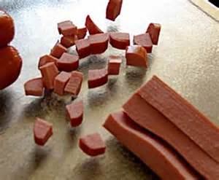](https://images.search.yahoo.com/images/view;_ylt=AwrB8o_K.htVvEwAgHeJzbkF;_ylu=X3oDMTIzODcycjA3BHNlYwNzcgRzbGsDaW1nBG9pZAM1ZThhMDQ0ZTE0ZGViMzE0MTg2NDZmZDY0ZTIyMWNmNQRncG9zAzIxBGl0A2Jpbmc-?.origin=&back=https://images.search.yahoo.com/search/images?p%3Ddiced%2Bup%2Bdog%2Btreats%26n%3D60%26ei%3DUTF-8%26fr%3Dsfp%26fr2%3Dsb-top-images.search.yahoo.com%26tab%3Dorganic%26ri%3D21&w=320&h=264&imgurl=smartdog.typepad.com/.a/6a00e54fae153788330120a6971779970b-320wi&rurl=http://smartdog.typepad.com/smart_dog/2009/11/makeathome-cheap-and-easy-dog-training-treats.html&size=18.0KB&name=Next,+chop+the+hot+%3cb%3edogs%3c/b%3e+into+pea-sized+bits.&p=diced+up+dog+treats&oid=5e8a044e14deb31418646fd64e221cf5&fr2=sb-top-images.search.yahoo.com&fr=sfp&tt=Next,+chop+the+hot+%3cb%3edogs%3c/b%3e+into+pea-sized+bits.&b=0&ni=288&no=21&ts=&tab=organic&sigr=130rdjit1&sigb=14ddqk8j3&sigi=1203demmk&sigt=11jg4b72a&sign=11jg4b72a&.crumb=DeRLgCB3x3X&fr=sfp&fr2=sb-top-images.search.yahoo.com)**Training Treats**

Training treats must be desirable enough to compete with the distractions of other dogs, people and excitement.   
  
Examples:

* Packaged dog training treats
* High-value kibble
* Beggin’ strips
* Freeze-dried liver
* Hot dogs
* Cheese

Treats need to be broken into tiny pieces, smaller than the size of a pea. Feed one piece at a time. This will allow you to dole out many treats in a session without causing the dog to have stomach upset.

***If a dog is on a special diet, they will not be able to have treats. Their prescription kibble can be used as their reward.***

**Teach a Dog to Sit:**

Sit is a great command to start with. Many other behaviors can be taught once a dog sits reliably.

The hand signal is an open palm toward the sky, bending your elbow at the waist over the dog’s head.

1. [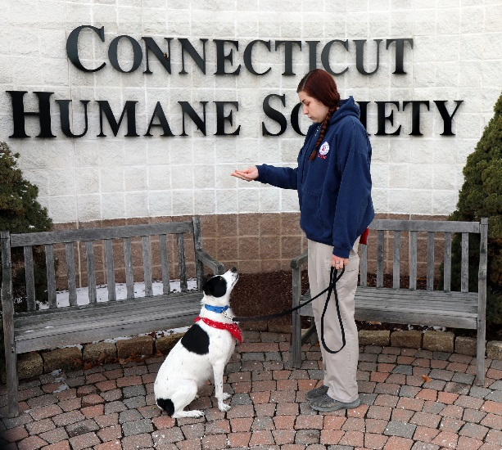](https://images.search.yahoo.com/images/view;_ylt=AwrB8pgg9RtViUkAjS.JzbkF;_ylu=X3oDMTIzaGphcDM5BHNlYwNzcgRzbGsDaW1nBG9pZAM5MGFiY2E3OWJjYWRlNGQ3OGM4NDk1OGU3MjM4OTYxZARncG9zAzEyBGl0A2Jpbmc-?.origin=&back=https://images.search.yahoo.com/search/images?p%3Dcanine%2Bhand%2Bsignal%2Bfor%2Bsit%26fr%3Dsfp%26fr2%3Dpiv-web%26tab%3Dorganic%26ri%3D12&w=252&h=269&imgurl=www.bordercollierescue.org/Members/Sign/Images/Sit1.jpg&rurl=http://www.bordercollierescue.org/advice/Content/UniCommands.html&size=44.3KB&name=...+command+a+page+will+open+in+a+new+window+with+more+detail+%3cb%3ehand%3c/b%3e+%3cb%3esignal%3c/b%3e&p=canine+hand+signal+for+sit&oid=90abca79bcade4d78c84958e7238961d&fr2=piv-web&fr=sfp&tt=...+command+a+page+will+open+in+a+new+window+with+more+detail+%3cb%3ehand%3c/b%3e+%3cb%3esignal%3c/b%3e&b=0&ni=21&no=12&ts=&tab=organic&sigr=12184ukhf&sigb=13fsb3usm&sigi=11n2e7ah1&sigt=12nd0cqvu&sign=12nd0cqvu&.crumb=DeRLgCB3x3X&fr=sfp&fr2=piv-web)Find a quiet area with no distractions.
2. Hold a highly desirable treat between your thumb and pointer finger.
3. With your palm facing upward in front of the dog’s nose, say “Sit” then slowly raise the treat up above their head.
4. As the treat rises over their head, the dog will naturally look up to follow it which will cause them to sit.
5. When the dog’s rump hits the floor, immediately say “Yes!” and reward with the treat.
6. Repeat, repeat, repeat.
   1. As the dog starts to learn what you are asking of him, he will sit for the treat faster and faster.
7. Once the dog reliably sits on command, continue to say “Yes!” when the dog sits but vary how often you reward with a treat.
   1. Reward with praise and pets instead of treats.
   2. When weaning off treats, mix it up. First offer a treat every other time they sit, then after sitting three or four times in a row, then back to every sit. This way the dog never knows when to expect a treat and will work for it every time.

**Troubleshooting:**

If the dog backs away from the treat rather than looking up at it, hold them on a shorter leash and take one step forward toward the dog to create spatial pressure.

Never forcibly push the dog into a sit.

**Advanced:**

Once the dog sits reliably on command, introduce an implied “stay.” Say “Yes!” immediately when they sit, then give multiple treats while they stay seated. Say “Okay!” and allow the dog to stand back up. Continue to increase the amount of time they stay sitting by using multiple treats and increasing the amount of time in between feeding each treat. Always release the dog with “Okay!” This will teach the dog that when they sit they are to stay in that position until released.

**Teach a Dog to Lie Down:**

Down is best taught once a dog already knows how to sit reliably.

The hand signal is an open palm facing down starting at the waist and lowering toward the ground.

1. 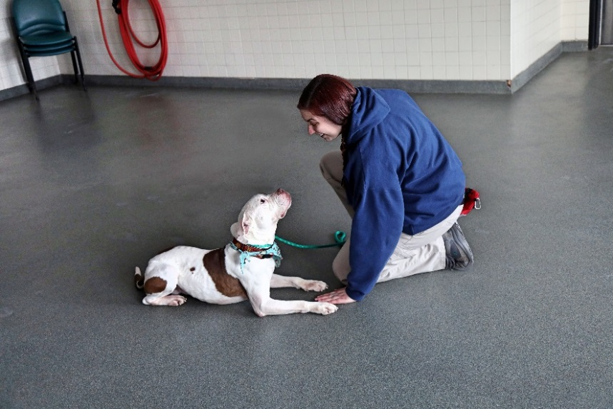In a quiet area, put the dog into a sitting position.
2. Hold a treat between the palm and thumb of your hand and with your palm facing downward say “Down” then slowly move the treat from the dog’s nose down to the ground between their front paws.
3. Once the treat is there be patient; it may take a few seconds for the dog to realize that it would be more comfortable to eat lying down.
4. As soon as the dog is in the down position say “Yes!” and allow them to eat the treat.
5. Repeat, repeat, repeat.

**Troubleshooting:**

If the dog does not lie down, try moving the treat between their paws closer toward them, almost so it is under their body. This will usually cause them to have to lie down to follow the treat.

You can also try kneeling on one knee with your other leg arched. Use a treat to lure the dog under your arched leg to get the treat. Give the reward once they lie down.

If that doesn’t work, simply wait until you see the dog lie down, then say “Yes!” and follow immediately with a treat and praise.

**Advanced:**

Once the dog is reliably lying down on command, build in an implied stay. Put the dog in the down position, say “Yes!” immediately then give multiple treats while they continue to stay down. Then say, “Okay!” and allow the dog to stand back up. Continue to increase the amount of time they stay down by using multiple treats and increasing the amount of time in between feeding each treat. Always release the dog with “Okay!” This will teach the dog that when they lie down they are to stay in that position until released.

**Teach a Dog to Come:**

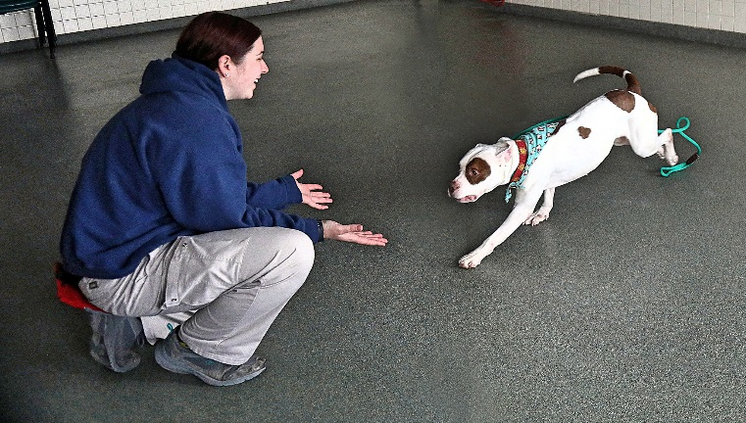Teaching a dog to come when called may be the most important command they learn. If the dog ever gets loose, a “Come” command may be the difference between a tragedy and a happy reunion.

1. Take the dog to a room or fenced area that is free from distractions and drop the leash.
2. Walk a short distance away from the dog then using the dog’s name call “Max, Come!” in a loud, happy voice.
3. As soon as the dog starts moving towards you say “Yes!”
4. Once the dog reaches you immediately take them by the leash or collar and give a bunch of small treats then say “Okay!” and release them.
5. Repeat, repeat, repeat, increasing your distance from the dog as time goes on.

**Troubleshooting:**

Be aware of the tone of your voice. The key is to sound happy, not angry!

Try kneeling down as you call “Come!”

**Advanced:**

Once the dog reliably comes when called, practice in an area with more distractions such as other people or animals. The use of a long-lead is useful if you are working outside.

**Behavior Modification Protocol**

**Barrier Reactivity**

**Objective:** Condition dogs to sit quietly when approached in their kennel. This is used for dogs that bark, jump or lunge when people approach them in their kennel.

**Program Instructions:**

1. Approach the front of the kennel in a non-threatening manner (turned to the side without making eye contact) while holding out a treat towards the dog.

2. If the dog approaches you calmly (no barking, lunging or jumping) say “yes!” and immediately toss them the treat through the bars.

a. Only toss them a reward when all four paws are on the floor.

5. If the dog displays any negative behaviors, say “nope” and turn your back to the dog and walk away. Approach the kennel and begin again.

6. Once the dog is reliably staying calm when you approach, introduce the “sit” command.

* 1. If the dog does not know the “sit” command, take them to a quiet area to teach it to them.

7.If the dog sits, say “yes!” and immediately toss them the treat through the bars.

* 1. If the dog doesn’t sit, say “nope,” turn away from the dog and walk away. Approach the kennel and begin again.

7. Continue practicing this protocol until the dog reliably approaches the front of the kennel and sits calmly when approached. Over time the dog will be conditioned to do this without needing a verbal cue or hand signal.

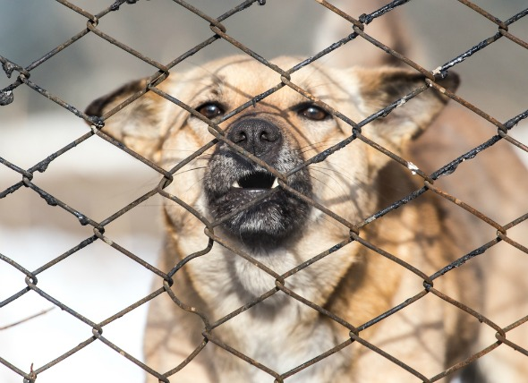

**Behavior Modification Protocol**

**Reactivity towards Other Dogs**

**Objective:** Modify the behavior of dogs that are reactive or leash aggressive toward other dogs. The goal is to be able to walk calmly around other leashed dogs at a distance without aggressive displays.

[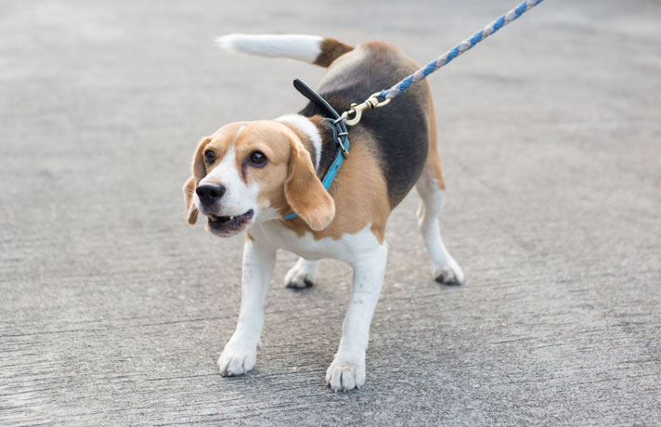](http://www.google.com/url?sa=i&rct=j&q=&esrc=s&source=images&cd=&cad=rja&uact=8&ved=0ahUKEwjb1ueJ7PvPAhWCSD4KHVJvBxwQjRwIBw&url=http://petcha.com/pet_care/10-tips-to-teach-your-reactive-dog-to-stay-calm/&psig=AFQjCNHeZOwNcOnumtOQznBCsWTDwvR8DQ&ust=1477687182487346)**Program instructions**

1. Bring the dog to an area where they can see other dogs from a distance. For example, walk them towards the play yard while another dog is in the fenced-in area playing. Stay far enough away that the dog can see the other dog but is not reacting negatively. If the dog becomes reactive you have gotten too close. The dog should be showing little to no reactivity before moving on to the next step.

2.Get the dog to focus on you. You can show them a treat or call their name excitedly.

3. Say “yes!” immediately once the dog is focusing on you and not the other dogs, then give them a treat within one second.

4. Once the dog is successful, decrease the distance between the two dogs and repeat the above procedure.

5. Continue to decrease the distance according to the dog’s success and repeat the above procedure.

**Notes:**

Set the dog up for success by avoiding congested areas and other dog walkers.

Watch the dog for signs that they are about to react, such as staring hard at the other dog, moving their body weight onto their front feet, piloerection (hair standing on end). If you see these signs, you are too close.

If you come upon a dog you were not prepared for, tell your dog “Let’s Go” and quickly walk in the opposite direction. Praise and treat once the dog recovers and refocuses on you.

DO NOT jerk the leash, yell at, or grab an agitated dog. Stay calm and use steady pressure to remove the dog with a leash.

**Behavior Modification Protocol**

**Building Confidence in Shy/Fearful Dogs**

**Objective:** Build confidence in dogs that are acting shy or fearful. The goal is to help them become more comfortable interacting with people.

**Instructions:**

1. Approach the dog in a non-threatening manner (turned to the side without making eye contact). Kneel on the ground with one knee up to make yourself look smaller and less intimidating.  
 a. Do not sit directly up at the kennel door.

2. In a soft, happy voice, call the dog to you by their name and show them a yummy treat in your hand.

3. If the dog moves closer to you, say “yes!” and toss a treat towards them.

4. If the dog moves away from you or doesn’t approach, continue to kneel patiently outside the kennel. Any time they look towards your or take a step towards you, say “yes!” and toss a treat towards them.

5. As the dog becomes more confident, toss the treats closer and closer to the front of the kennel.

6. Continue practicing with this method until the dog approaches the front of the kennel willingly.

[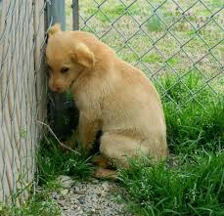](http://www.google.com/url?sa=i&rct=j&q=&esrc=s&source=images&cd=&cad=rja&uact=8&ved=0ahUKEwjEmfyA8P3OAhXDZiYKHWU7DqEQjRwIBw&url=http://trainingyourbestfriend.com/fearful-fido/&bvm=bv.131783435,d.dmo&psig=AFQjCNGZ9b9MQz1lgeMdBBtdinLB9VFO1w&ust=1473358939140067)**Note:** Always go slow and be patient.

**Additional Method:**

1. Take the dog into a quiet room or enclosure.

2. Have a seat (on a bench or chair, not on the floor) and softly read aloud while ignoring the dog.

3. If the dog approaches, say “yes!” and toss a treat to them.

4. If the dog gets close enough to touch, put some treats in the palm of your hand and slowly hold it out for them to take the treats out of your hand. While the dog is eating out of your hand, use your other hand to gently pet them under the chin.

**Note:** Patience is the key! Never force the dog to be touched. Only do so if they approach willingly and are comfortable with it. If they move away from your touch, do not force it. Watch for signs that the dog is uncomfortable such as a tucked tail, lip licking, ears pinned back or avoidance.

If the dog does not want to exit the kennel, use treats to lure them out.

If the dog won’t walk on the leash, DO NOT drag them. Use treats to try to lure them forward.

**Behavior Modification Protocol**

**Inappropriate Play Program**

**Objective:** Teach the dog to play in a less physical and more appropriate manner with humans. When a dog starts jumping up, growling or becoming mouthy, a “time out” is used to teach the dog that play will end when they become inappropriate.

**Program Instructions:**

1. Take the dog to the fenced outside play area and drop the leash.
   1. Bring a carabiner with you if the play area does not have a catch pen.

2. Engage the dog in a polite game of chase.

3. The moment the dog becomes inappropriate (jumping on you, moderately mouthing, mounting, or body slamming) say “nope” in a firm (not angry) tone then lead them by the leash into the catch pen, closing them in by themselves for a “time out.”

a. If the outdoor play area is not equipped with a catch-pen, use the carabiner attached to the handle of   
 the leash to clip them to the fence and walk away to give them their “time out.”

4. Do not give any attention to the dog during the “time out.” Turn your back to them and do not speak to them.

5. Wait one or two minutes for the dog to settle down, then open the door to the catch-pen and let the dog re-engage in play with you.

[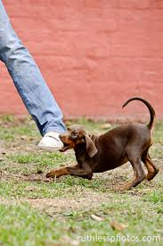](http://www.google.com/url?sa=i&rct=j&q=&esrc=s&source=images&cd=&cad=rja&uact=8&ved=0ahUKEwjNgMvj8P3OAhXBJiYKHaieCBMQjRwIBw&url=http://leemakennels.com/blog/dog-behaviour/the-importance-of-bite-inhibition/&bvm=bv.131783435,d.dmo&psig=AFQjCNH_0WcELlqUg8HPVl-sWfyfC_nXUg&ust=1473359126266329)

6. Repeat the sequence for 10–15 minutes.

**Note:** Since the reward for the dog in this program is play, you do not need to use treats as a reward.

If the dog becomes increasingly inappropriate (hard mouthing, obsessive mounting, etc.) give them a final “time out” to allow them to calm down, then return them to the kennel.

If you feel that you are unable to control the dog, use your walkie talkie to call for assistance.