

Foster Volunteer Handbook
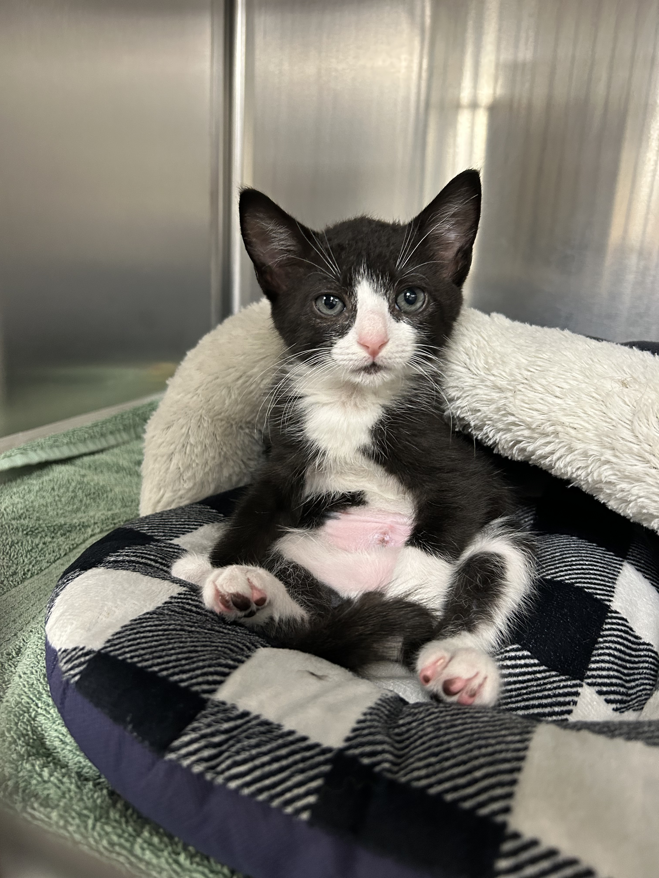
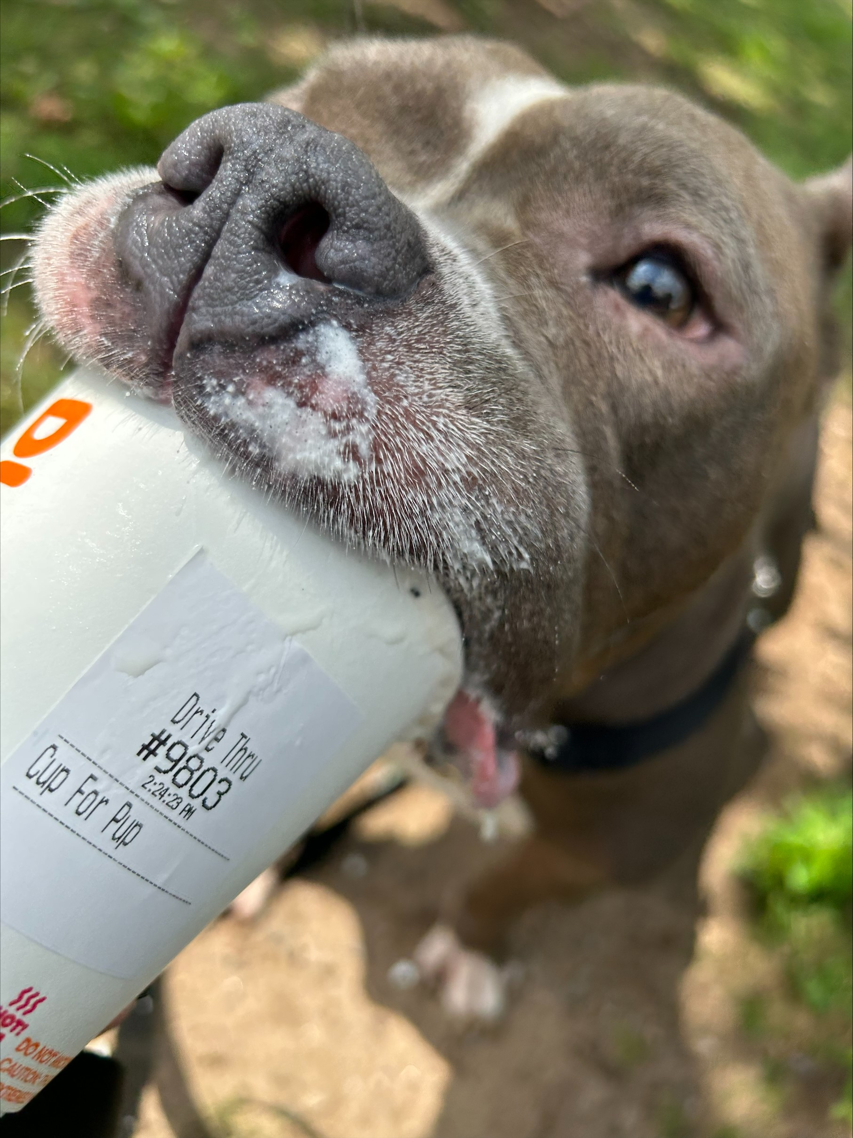
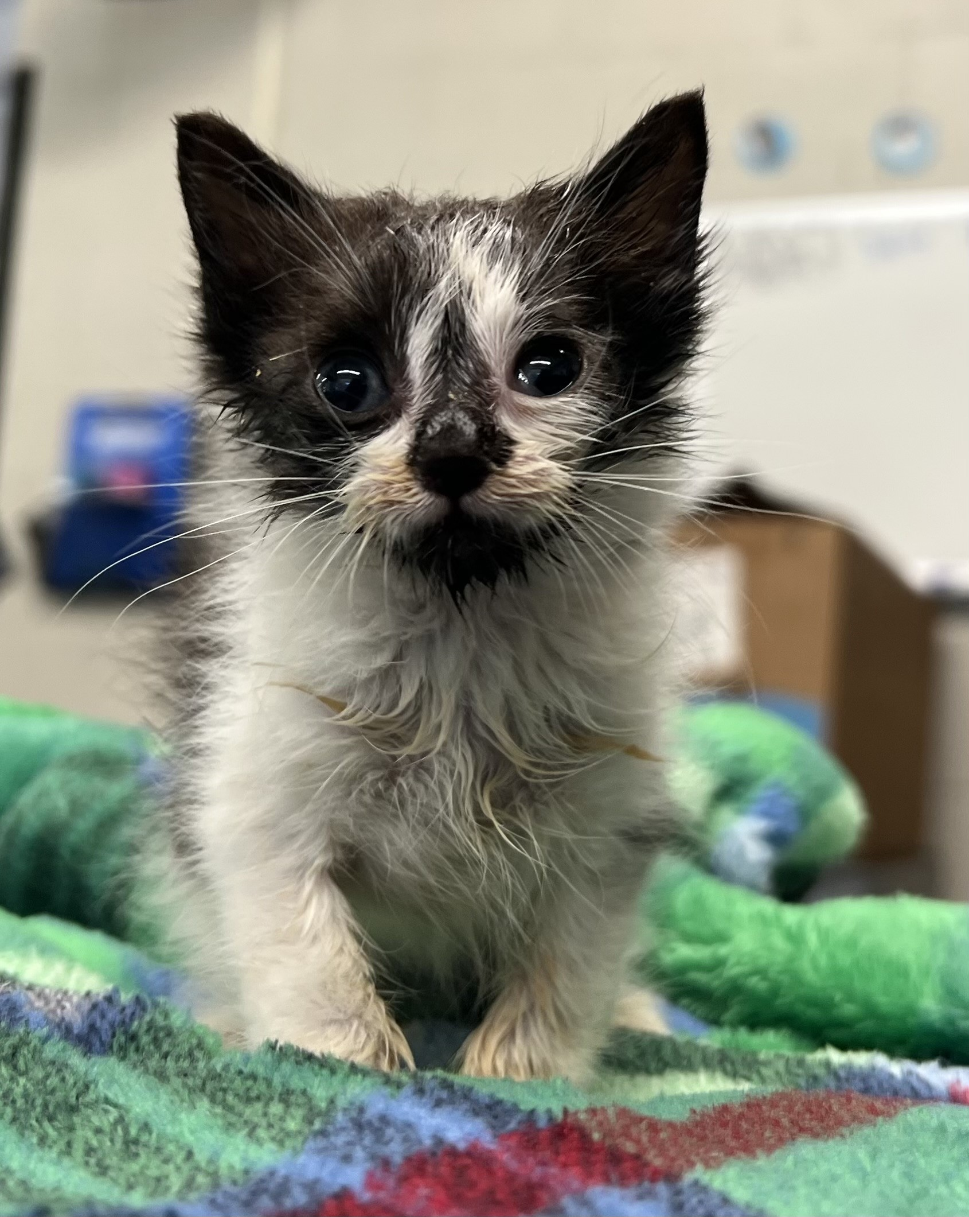


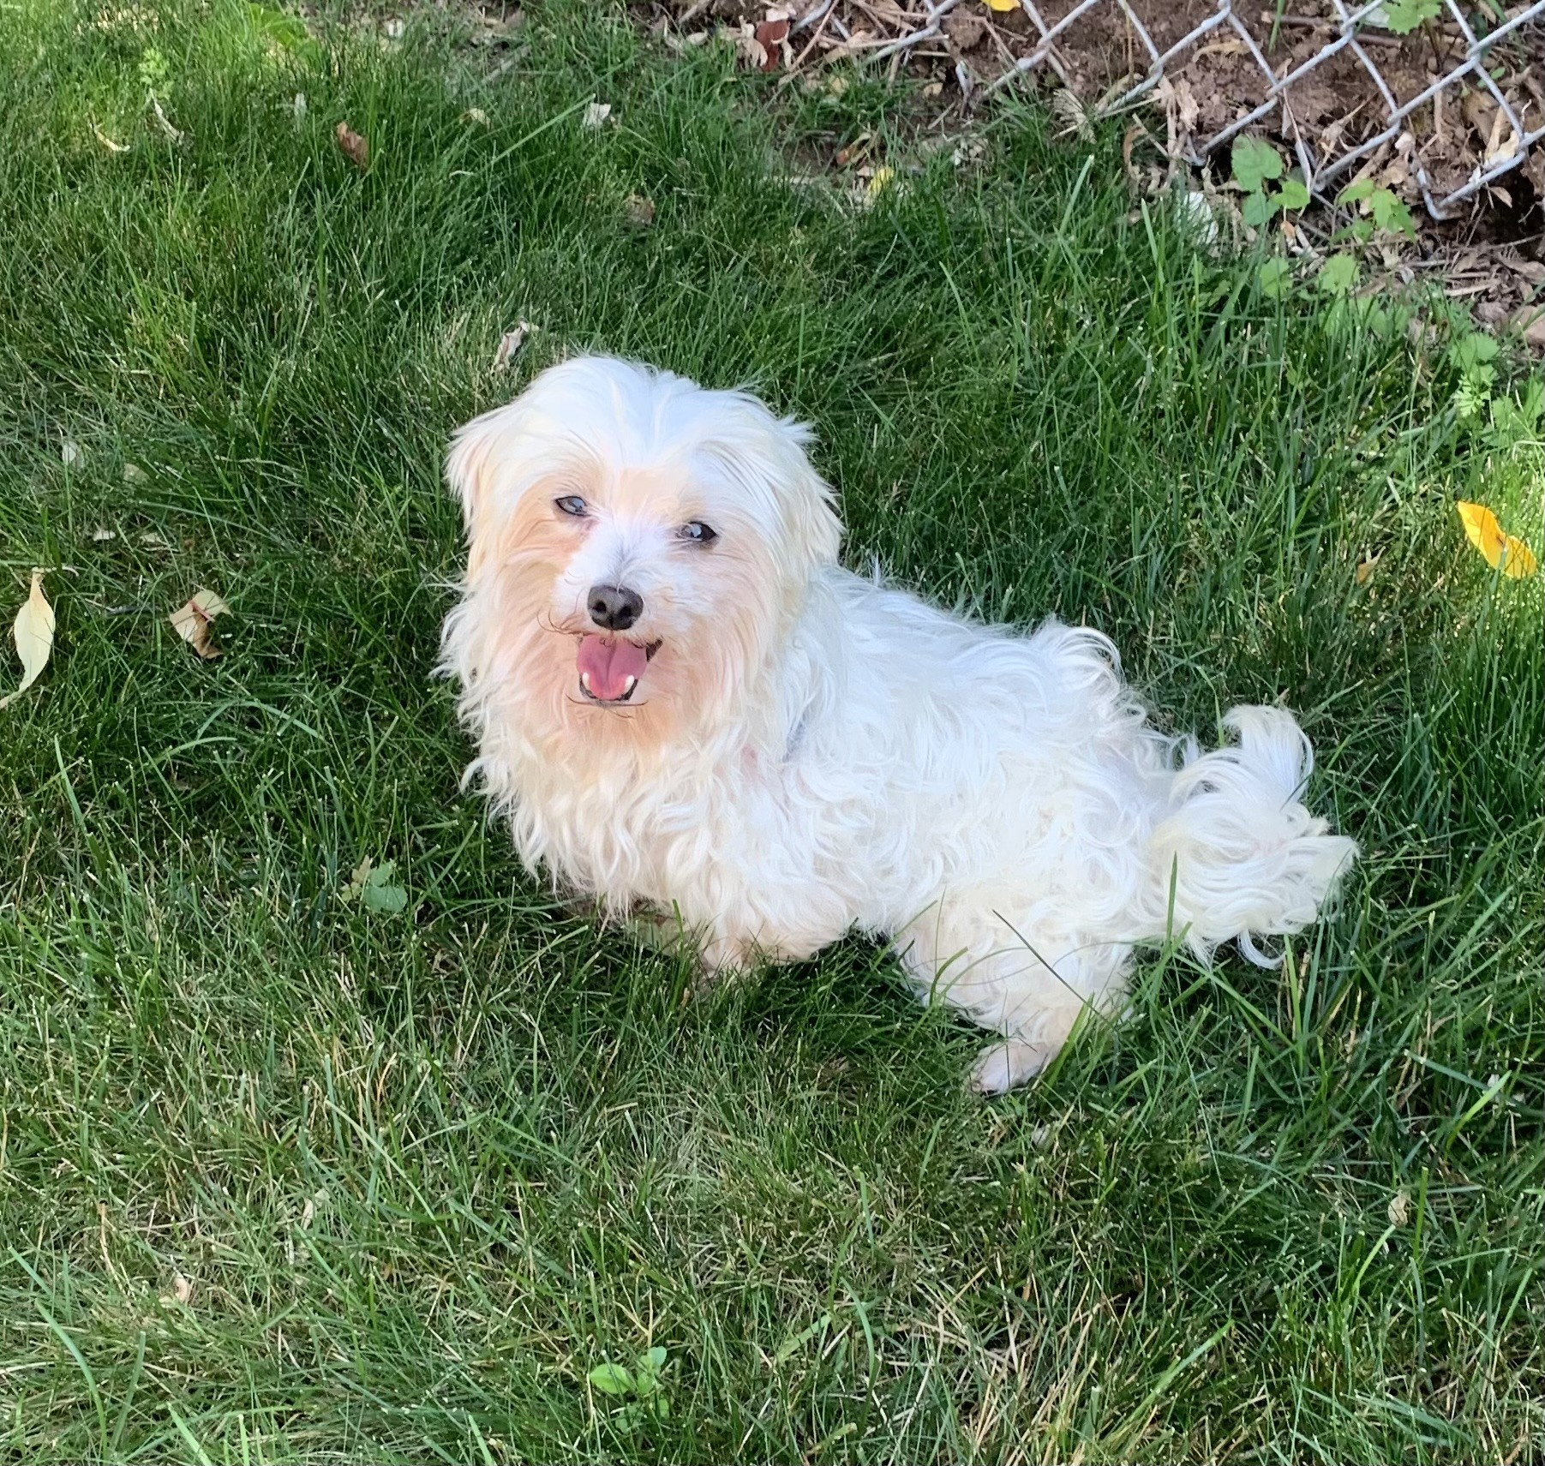
After-Hours Emergency Facilities:
Foster volunteers should use the following facilities for emergencies when CHS is closed:

Pieper Memorial Veterinary Center
730 Randolph Road, Middletown
860-347-VETS (8387)
Bolton Veterinary Hospital
222 Boston Turnpike, Bolton
860-646-6134 or 860-456-4298

Pieper Memorial Vet Specialist
51 Boston Post Road, Madison
Monday – Sunday: 8am-10pm
860-390-5340

VCA Vet Referral and Emergency Center
123 West Cedar Street, Norwalk
203-854-9960 or 203-245-8511

See page 3 for complete instructions if emergency care is needed.

Foster Coordinator Contacts:
Newington:
Michelle Green, Foster Coordinator
860-594-4500 x. 6330
Cell: 860-573-9894 (Tu-Sat only)
newingtonfoster@cthumane.org

Westport:
Delia Nolan, Assistant Shelter Manager
860-594-4500 x. 6603
dnolan@cthumane.org

Waterford:
Denise McNichol, Assistant Shelter Manager/ Volunteer Coordinator
860-594-4500 x. 6504
dmcnichol@cthumane.org

CHS Locations:
Newington 8:45am-4:30
701 Russell Road
Newington, CT 06111

Waterford 9am- 4:30
169 Old Colchester Road
Quaker Hill, CT 06375

Westport 9am-5:30 Tues-Sat
455 Post Road East
Westport, CT 06880

PREPARING FOR YOUR FOSTER ANIMALS
CHS will provide all necessary supplies for their stay. Some volunteers prefer to purchase some basics to limit the number of items brought back and forth between visits.

PICKING UP YOUR FOSTER PET
Please arrive on time and allow about 15 minutes to complete a foster pick-up so that your Foster Coordinator can review any pet-specific instructions.

We use a mobile checkout process when signing out animals. All necessary documents will be sent to you via email or text. You will need to click the link you receive within a couple hours to complete the checkout process, otherwise the link expires. If this happens, please reach out so we can resend it.

CARING FOR YOUR FOSTER
First Day
When you first arrive home with your foster animal, allow them some time and space to adjust to the new environment and provide hiding places for cats. Don’t bring dogs to pet stores or other busy areas and don’t invite family and friends over to meet the pet right away.

Daily Care
- Follow feeding instructions
  - Please do not change a pet’s feeding protocol unless instructed
- Spend time socializing
  - Human contact is extremely important for the development of young animals
  - Socialization from a young age helps animals to become easier to handle when they are older
Routine Wellness Check-Ups
Young animals must be seen every two weeks for wellness check-ups, routine deworming, and vaccines. All foster animals are seen once every month by a veterinarian, sooner if showing signs of illness. Please arrive on time for scheduled appointments and give notice if you need to cancel or reschedule. Appointments may take 30 minutes or more. Please complete a Progress Report (recheck) at least 24-48 in advance so a vet can be available if needed.
MEDICAL CONCERNS AND EMERGENCIES
Medical Concerns
It is important that medical concerns get addressed quickly to prevent symptoms from worsening. Young animals are very fragile, and many medical concerns can be life threatening.

All medical decisions must be handled by CHS veterinary staff. Do not administer any medication without approval or attempt any “home remedies.”

Immediately report concerns to your foster coordinator:
- Vomiting/Diarrhea/Constipation/Blood in stool
  - Refer to the Fecal Scoring Chart when reporting
- Sneezing/Coughing
- Eye or ear odor or discharge
- Wheezing or struggling to breathe
- Loss of appetite
Note: If the medical staff asks to examine the animal, the appointment should be scheduled as soon as possible.
- Lethargy
- Skin issues
- Bleeding
- Limping

Emergencies
A medical emergency is a life-threatening situation that requires immediate care, such as:
- Severe injury or trauma
- Difficulty breathing/blocked airway
- Severe bleeding
- Continuous vomiting
- Lethargy/listlessness

In the event of an emergency, call your Foster Coordinator immediately. Animals must be brought to CHS for treatment during our normal business hours. If after hours, please bring your foster pet to the closest clinic we have a contract with (list on page 2).
- You are required to call ahead.
- Be prepared to forward the animal’s medical records from the mobile checkout on arrival to the hospital to prove the animal belongs to CHS.
- The vet clinic will bill CHS directly. Do not set up an account under your own name.
- Volunteers are not permitted to make medical decisions at the vet.
  - The veterinarian will act objectively and according to the signed agreement with CHS that they have on file.
- Foster Volunteers are responsible for notifying their foster coordinator following a trip to the emergency clinic. Please call CHS in the morning and speak directly to your Foster Coordinator or the manager on duty.

*NOTE: If the emergency clinic staff is not aware of their policy with CHS, please have them reference the Connecticut Humane Society account/file.

Unassisted Death
In the unfortunate event that a foster animal passes away at your home, please call and inform us right away. The body should be returned to CHS for proper disposal. Infants do not have a fully developed immune system or are sometimes born with internal abnormalities and may not survive despite the best care and medicine.

BEHAVIOR
CHS practices positive reinforcement training which uses treats, praise, and other motivating items like toys to encourage good behavior. Volunteers must never use physical force to reprimand a foster animal. Behavior resources can be found at CThumane.org/FosterResources

Immediately inform your foster coordinator of any behavioral issues that you are experiencing with your foster pet, such as:
- Destructive behavior
- Inappropriate urination or defecation
- Mouthy behavior (including kittens and puppies)
- Extreme shyness or withdrawn behavior
- Separation anxiety
- Fear, aggression, biting, scratching

Reporting a Bite Incident
If a foster pet bites or scratches, contact CHS immediately to report the incident. The animal will need to be returned for a mandatory quarantine in accordance with state rabies laws.

Housetraining
We cannot guarantee that any animal is housetrained. Young animals are not usually housetrained. You can start house training once they begin eating solid food at around 4-5 weeks of age. Visit the Foster Resources page for housebreaking information and litter box tips.

RETURNING YOUR FOSTER ANIMAL(S)
All foster animals remain the property of the Connecticut Humane Society and must be returned for adoption. Upon return, make sure to:
- Return any supplies that were provided
- Complete a Foster Report Card.

If an emergency arises and you are not able to keep the foster animal until their scheduled return date, call to schedule the drop-off. Do not leave fosters in the care of pet-sitters, neighbors, or family members without first discussing with your Foster Coordinator.

Adoption Policy
If you would like to adopt your foster pet, let your Foster Coordinator know as soon as possible. We will do our best to let you know in advance if the animal already has an adopter.

Disease Control between Foster Groups
Foster animals may be harboring an illness that can live in the environment. To prevent disease transmission between foster groups it is important that the foster room is thoroughly cleaned between assignments.

SCHEDULED CLOSING & INCLEMENT WEATHER
CHS closes for major holidays and occasionally for inclement weather. Foster volunteers who have a scheduled appointment will be contacted if there is a closure or delay. There will also be a special recording posted to the phone system.

SOCIAL MEDIA POLICY
When your foster pet becomes available for adoption, you may post their photos with a link to their adoption page on our site. Please do not post pictures or information about animals that are not available for adoption.

