Fur Squad
Training Program
2017 Edition
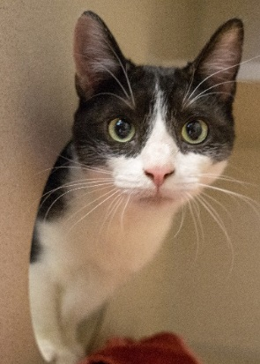
Objective:
Our goal for this program is to provide socialization and positive interactions for cats that are excessively shy, fearful, stressed out, or undersocialized. Volunteers will use behavior modification techniques to teach these cats to trust humans and to approach people willingly. These techniques will help the cats become more appealing to potential adopters and will help to shorten their length of stay in the shelter. With time, effort and patience, some cats that are initially fearful of human interaction may even become social lap cats!

Cats in the Program:
Cats that could most benefit from behavior modification will have a “Fur Squad” sign hanging on their cage, in addition to a Fur Squad Log attached to their paperwork. To limit the risk of bite and scratch incidents, only volunteers that have successfully completed Fur Squad training may interact with cats with this sign. Fur Squad volunteers will be given special name tags.
Please focus on the Fur Squad cats during your shift. If all Fur Squad cats have been worked with during your shift, you may choose other cats to work with. If you see a cat that you feel is a candidate for the Fur Squad program, please bring it to the attention of the Behavior Department.
Training Overview
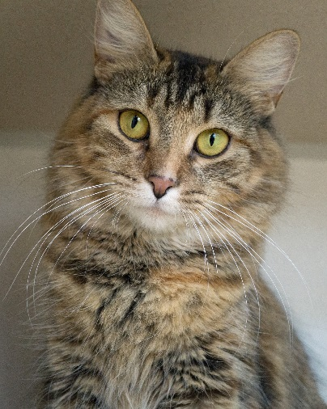
What Methods Will We Use?
As a Fur Squad volunteer, your job is to earn the trust of the cats in this program. One of the most effective tools to win over a cat is yummy canned food offered as a reward for positive interactions. The behavior modification guidelines in this manual will show you how canned food can be used to help Fur Squad cats overcome their fears. Clicker training is another method that uses a food reward to teach cats to exhibit more pro-social behaviors.
What type of canned food should we use?
Start off using canned I/D as their reward for positive interactions. If they do not show an interest in I/D, you may try canned A/D. If they do not seem overly excited about either food, check with the Behavior Department for an alternative “junk” canned food. If the Behavior Department is aware of their food preference, it will be marked on their Fur Squad Log. If a cat is on a special diet, they may have the canned version of their food as their treat.
Improving Success Rates:
- Read the cat’s paperwork prior to working with them for information about their history and behavior.
- Pay close attention to information on the Feline Grading Summary sheet and the Fur Squad Log.
- Have patience! Some cats will take multiple sessions to show even marginal progress. End the session if you are feeling anxious or frustrated.
- Cats can become overstimulated, so keep training sessions short. Five to ten minutes per cat is ideal. It is better to work with a cat in multiple short sessions than in one long session.

Recording Your Progress:
Use the Fur Squad Log attached to the cat’s paperwork to record notes about your interactions. Because you are working with these cats regularly, we are relying on detailed information from you to assess the cats’ progress and stress level in the shelter.
Safety:
Any animal that is feeling fearful or stressed may respond with defensive aggression. Cats in the Fur Squad program have a much higher potential for displays of aggression than well-adjusted cats. It is important that Fur Squad volunteers proceed with caution to avoid bite or scratch incidents. Not only will a display of aggression be a setback for the cat’s progress, it may result in a state-mandated quarantine for Rabies observation and may also affect their chance at adoptability.
Fur Squad volunteers must always pay close attention to the cats’ body language for signs that they have had enough, such as tail flicking, dilated pupils, or hair standing on end. Listen for warning signs such as growling or hissing. If the cat is giving you signs that they have had enough, end the session. Always try to end on a positive note by offering them a little canned food.
If the cat is displaying aggressive behavior such as swatting or lunging, make a note of it on their Fur Squad Log and report it to the Behavior Department. If you are bitten or scratched, you must report the incident immediately to the manager on duty and complete an incident report.

Disease Prevention:
To prevent the transmission of disease in the shelter, Fur Squad volunteers must follow all the guidelines set forth in our cat cuddling program.

Cats should be handled in the following order:
- Healthy kittens
- Healthy adult cats
- Cats recovering from an Upper Respiratory Infection
- Cats that are currently being treated for an Upper Respiratory Infection

Fur Squad volunteers will be given access to some areas of the building that are off-limits to cat cuddlers. You will be shown these areas during your hands-on training. Always pay attention to the color-coded room signs and follow the instructions on the sign regarding required attire and hand-washing guidelines. At a minimum, hands must be washed after each cat interaction, prior to marking on their paperwork.

Additional Responsibilities:

You may provide the cats with additional water, blankets, and toys. Please feel free to scoop their litter box if you can do so safely. Please do not provide the cats with hidey houses or privacy covers without the approval of the Behavior Department. These may not be appropriate for all cats.

Feline Body Language:
You can pick up a lot of cues from a cat to determine how she’s feeling. During each session, watch the cat closely for signs of what her body language is telling you. The chart below gives some examples of what feline body language may mean, but each cat is an individual, so try to keep in mind that these are general guidelines only.
 | Confident or Friendly | Relaxed or Curious | Undecided or Nervous | Scared or Fearful | Agitated/ Aggressive
Ears | Both ears up, turned slightly to the side in a natural position. | Both ears up, turned slightly to the side in a natural position, or turned forward if focused on something. | One ear up, one back. | Ears down, pinned against the head. | Ears up and twisted backward.
Eyes | Open and soft. Pupils a normal size. | Returns your blink. May be squinting. | Looking away. | Wide-eyed stare. Pupils may be enlarged. | Glaring. Eyes may be squinting.
Body | May be walking around freely | Lying or sitting in relaxed posture. Paws may be tucked under body or crossed. | Stiff body. | May be lying down with head low and head and body stiff or may be standing with back arched. May have tail and paws tucked under body. | Stiff body
Tail | Tail is hoisted high, tip may be twitching or bent in a question mark. | Tail is lying naturally, may be twitching just at the tip. | Tail may be held low. | Tail may be tucked under the body, raised and puffed up, or whipping back and forth. | Tail may be positioned straight down (parallel to the legs) or may be puffed up or whipping back and forth.
Vocalization | May be mewing or meowing. | May be purring or chirping. | May be hissing. Whiskers may be pulled back. | May be hissing or growling. | May be hissing, growling, spitting or yowling.
Movement | May approach for attention. | May be grooming, kneading, rubbing their head against the cage, a hand or an object, soliciting attention. | May be licking their lips. Does not approach. May be lying firmly against the back of the cage. | May be biting or striking. | May be biting or striking.  May be moving in a darting manner.
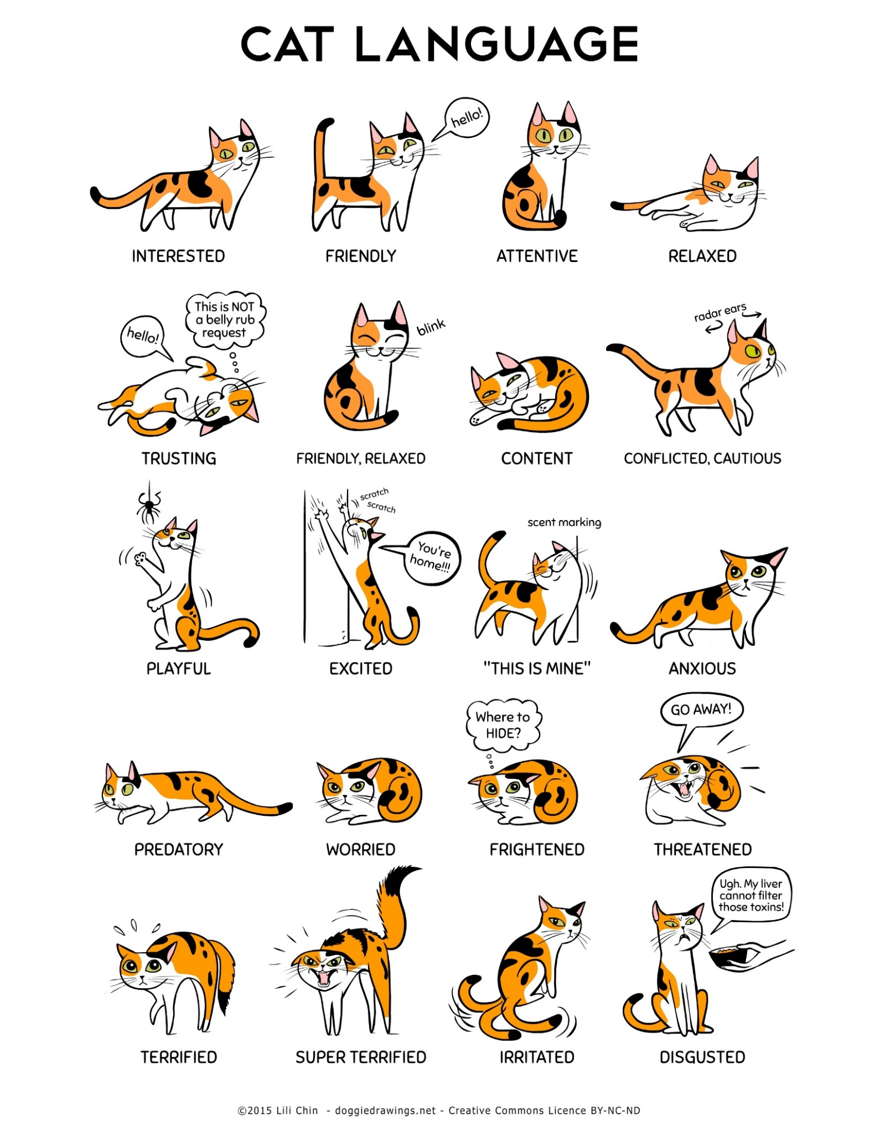
Human Body Language:

Not only must you pay close attention to the body language of the cat, you must also be aware of the non-verbal signals you are sending. If you frighten the cat, you will reinforce their fear of people and cause them a setback.

In order to appear non-threatening, you should:
- Turn your body so you are not facing the cat head-on.
- Avoid staring the cat in the eyes. Blink slowly at the cat instead.
- Speak in a soft, soothing voice.
- Move slowly and avoid sudden movements.
- Turn off cell-phone ringers.
- Open and close cage doors gently to avoid loud banging.

Behavior Modification Techniques for Undersocialized Cats:
The following lesson plans should be adhered to when interacting with cats in the Fur Squad program. Lessons should be worked on in chronological order. Do not skip ahead or move to the next lesson until you have had a success with the preceding lesson. These lessons have been adapted from Best Friends Animal Society.

Lesson One: Motivating the Cat with Food
The goal of Lesson One is to have an initial positive interaction with the cat. You should start every interaction with a Fur Squad cat with Lesson One.
- Place a small amount of canned food on the end of a wand (the end without the feathers or cloth), or on a tongue depressor.
- Slowly move the food tip of the wand about halfway into the cage. Wait to see if the cat will smell or lick the food. If not, slowly move the wand toward the cat’s nose. You want the cat to lick – not bite – the food. This may take some practice on the cat’s part.

Tips
- Never leave food in the cage. The cat should only receive the reward in your presence.
- If the cat does not show any interest in the food, move to a higher-value food.
- If the cat still does not show interest in the food, it may be a sign that he’s not motivated by food or that his appetite is suppressed due to stress. Even if a cat doesn’t accept food from you in the beginning, continue to offer the food on the wand at the beginning of each session. One day, the kitty may surprise you.
- If the cat strikes at the wand tipped with food, reapply the food and try again.
- If the cat is food-motivated, repeat lesson one a number of times at the beginning of each session to reinforce for the cat that it’s time to socialize. In a short time, the cat will begin to look forward to the interaction.
- Lay a paper towel down in the cage under the wand or tongue depressor. This will make it easier to clean up spills in the cage after the session.

Lesson Two: Petting with the Wand
The goal of Lesson Two is to get the cat comfortable with the wand and your presence with the cage door open.
- Start with Lesson One.
- Then, take the bare end of a feather wand and move it slowly into the cage, stopping about halfway into the cage. The wand should be level with or lower than the cat’s head. Watch the cat’s reaction.
- Keep the wand lower than the cat’s head and let the cat smell the wand. If the cat attempts to bite the wand, stop moving the wand for a few seconds; if necessary, move the wand so the cat cannot bite it. If the cat continues to attempt to bite the wand, move it out of the cage. You don’t want a confrontation with the cat. Go back into the cage with food on the wand and allow the cat to lick the food (Lesson One).
- Bring the wand back into the cage. Let the cat smell the empty end of the wand.
- Bring the wand up to the top of the cat’s head and attempt to touch the cat lightly with empty end of the wand. Starting at the top of the head between the ears (the forehead area), gently pet the cat with the wand. If the cat is receptive, work your way down the cat’s back. Next, pet around the side of the cat’s head and chin area using the wand.
- If the cat hisses or strikes, pull back a little, wait a few seconds and try again. Even if you only get to touch the top of the cat’s head, that’s progress. Next session, you may be able to pet the back of the cat’s head with the wand.
- If the cat continues to react negatively, then go back to a previous action to which she reacted positively and end the session. Some cats are resistant in the beginning of a new lesson, so you may have to do this repeatedly. Be patient!
- Once the cat is comfortable with being touched with the wand, gradually slide your hand down the wand so it is closer and closer to the cat. If the cat reacts negatively, go back to a previous action to which she reacted positively and try again.
- You want to end each session positively, so offer the cat a little canned food on the wand or a tongue depressor once you’ve finished the session.
- Once the cat is allowing you to touch her with the wand while your hand is close to her, move on to Lesson Three.
Tips
- Spray the wand with a pheromone like Feliway or touch the wand on some canned cat food. The scents make the wand more inviting to the cat.
- Some cats are mesmerized when you touch them on the forehead (between the eyes) with a wand. Other cats may hate being touched on the face or head.
- If the cat looks away when you pet him, he may be “in denial” – the touch is scary, so he’s pretending that you’re not touching him. You’ll want to make sure the cat is watching as you reach to touch and pet him with the wand.
- Notice whether the cat seems sensitive to touch on a particular area of her body, such as the chin or tail. Don’t avoid touching these areas, just work more carefully and gently with these spots.
- Each time you have a session, gently touch and pet the cat with the wand a little more.
- If the situation becomes unsafe (the cat tries to bite or strikes), end the session and notify the Behavior Department immediately.

Lesson Three: Petting with a Hand
In this lesson, you’ll progress to petting the cat with just a hand, without the presence of the wand. To do this, you’ll need to use food as motivation.
- Put canned food on the tip of your finger and move it slowly toward the cat. Rest your finger near the cat and wait for it to come to you.
- Most of the time, the cat will come to you and begin licking the food. If that doesn’t happen, slowly move your finger toward the cat’s nose, talking in a soothing tone the whole time. Entice the cat to eat by letting him smell the food.
- Once he’s eaten, slowly reach toward the cat with your hand level with his face (or lower) and with one finger touch the top of the cat’s head. If he reacts favorably, continue to pet the back of the cat’s head. If the cat prefers to be touched on the back, start there and work your way toward the cat’s head.
- If the cat reacts negatively at any point, go back to a spot where the cat reacted positively to your touch and try again. As always, go slow and be patient.
- End the session on a positive note by giving the cat some canned food.

Tips
- The places where you are able to touch and pet the cat should increase as you do more sessions. The goal is to get the cat comfortable with you petting him from head to tail with your hand.
- As the cat becomes more comfortable with petting, you’ll want to increase the amount of time spent on the petting session. Be careful that you don’t over-stimulate the cat, however, because that might cause the cat to bite or strike. Signs of overstimulation are the cat rolling or rubbing against you, moving with quick, darty motions, dilated pupils and acting overly-excited, much like a cat in heat does. Keep in mind that petting can be scary to the cat.
- Each cat is an individual, so you’ll need to watch for what the cat can tolerate while using gentle persistent persuasion so the cat can make progress.
- When the cat is comfortable with petting with your hand, go to Lesson Four.

Lesson Four: Picking up a Cat in the Cage
The first attempt to pick up the cat takes place in the cage. This can be a really scary step for the cat, so be prepared for the cat to react badly.
- Start this lesson by offering the cat food on your finger.
- Next, pet the cat.
- Next, scruff the cat and gently lift her front paws off the floor of the cage for a couple of seconds. (To scruff the cat, grasp the loose skin gently but firmly at the back of the neck above the shoulder blades.)
- Set the cat back down and pet her again.
- End the session on a positive note by giving the cat some canned food.
- Repeat this sequence for as many session as it takes for the cat to become comfortable with it.
- Once the cat is comfortable having the front paws lifted off the floor, repeat the lesson but instead of scruffing the cat, put one hand on top of the cat and slide your other hand under his belly. Try to lift the cat so that all four paws leave the cage floor, then gently set her back down. Do this for a few sessions until the cat is comfortable with it.

Tip
- If these sessions do not go well, the cat is not ready to be picked up and you need to build more trust with the cat. Go back to Lesson Three and work with the cat until she’s comfortable with petting and more trusting of your actions.

Lesson Five: Taking a Cat out of the Cage for Lap Time
Once the cat is comfortable with being picked up inside the cage, it’s time to practice picking the cat up and taking her out of the cage for lap time. Be prepared for some distress on the cat’s part. The cat thinks of the cage as a safe place, so the first time you take her out of the cage she may panic. In time, though, the cat will feel comfortable coming out of the cage and being held and being petted in your arms.
- Prepare a chair and have a towel handy to place over your lap to protect you in case the cat tries to “dig in.”
- Start the session by offering some canned food on your finger, then reach in and start petting the cat.
- Next, pick up the cat using one of the methods listed below. If the cat panics, put the cat down, pet her and try again. If the cat struggles excessively (tries to kick out of your arms), she’s not ready to be held. Go back to Lesson Four.
- Once you successfully remove the cat from the cage, sit on the chair with a towel on your lap and hold the cat on your lap. Keep one hand on top of the cat, near the head, ready to scruff her if necessary as you pet her. Place your other hand under the cat’s neck, in front of her chest. This positioning of your hands gives you better control over the cat.
- Ten to 15 seconds is a good length of time for the first session on your lap. You want the cat to understand and trust that you will return her to the cage, the place where she feels safe. You will be able to feel if she’s going to leap from your lap – something you don’t want to happen. If the cat is struggling some, return her to the cage and try again on the next session.
- As the cat becomes more comfortable in your lap over time, you can lengthen the lap time.
- When you put the cat back in the cage, you don’t want the cat to jump out of your arms and into the cage. Instead, place the cat back in the cage. You don’t want the cat to feel like she’s escaping from you.
- To end positively, reach in and pet the cat after you’ve returned her to the cage. And don’t forget to give the cat a little canned food.
Methods for Removing a Cat from the Cage
There are two methods that you can use to remove the cat from the cage. Use whatever works best for you and the cat.
Method 1 Scruff the cat with one hand; place your other hand underneath the cat and hold his front paws together with your fingers so he doesn’t grab onto the cage. Lift the cat out of the cage, holding the cat’s head up with the hand that’s scruffing him, and set him on your lap. You can take the cat out of the cage either tail first or sideways.
Method 2 Scruff the cat with one hand and slide your other hand between the cat’s back legs, supporting his belly. This is easier if the cat is turned away from you, with his tail facing you. The drawback to this method is that the cat will be better able to grab onto the cage as you’re taking him out. You will probably have to remove his paws from the side of the cage as he comes out.

Tips
- Putting the cat back in the cage is usually easier than taking her out, however, if the cat gets loose and is giving you signs that she doesn’t want to be picked up, you can toss a toy into the cage and the cat may follow it on her own. Or, use a towel to wrap the cat up to safely move the cat back into the cage.
- Scruffing allows you to have better control of the cat. If done properly, scruffing doesn’t hurt the cat and the cat seems to concede faster to being picked up. As kittens, their mothers carried them this way.
Clicker Training:
Clicker training is another method that can be used to help cats that are undersocialized. When used properly, a clicker can help to condition the cats to come to the front of the cage when approached. This will help them appear more appealing to potential adopters. Also, cats displaying extreme fear that cannot be handled safely can still be stimulated by clicker training through the cage door. Clickers are provided for Fur Squad volunteers at each CHS location.
Method:
- “Charge” the clicker by clicking, then immediately offer the cat a little bit of canned food on a tongue depressor or the end of a wand. The treat should be no larger than the size of a pea.
- Repeat over and over so the cat will learn that the click is always followed by a yummy treat. They will want to learn what it takes to make that click happen.
- Teach the cat to solicit attention by clicking any time they display a pro-social behavior. Click when the cat looks at you, approaches you, head-butts you, etc. Always follow the click immediately (within one second) with an offering of canned food.
- Eventually, the cat will learn that pro-social behaviors will earn them a reward and will be more likely to repeat these behaviors.
Tip:
- The sound of the clicker may startle cats that are especially fearful. You can try muffling the sound of the clicker in your pocket, armpit or belly, or try another clicker with a softer tone. If the clicker continues to cause a negative response in the cat, clicker training may not be the best method for that particular cat.
Advanced:
- Through clicker training, cats can be taught tricks such as targeting with their nose, sitting, giving their paw, jumping over obstacles and more. For more information about teaching cats tricks with a clicker, visit www.clickertraining.com.

Summary
The time that you spend working to socialize the shelter cats will have an impact on how quickly they are adopted and how quickly they settle into their new home. Additionally, training sessions provide mental stimulation for the cats during their stay at the shelter. Mental stimulation is important for decreasing depression and boredom and the negative behaviors that can result.
Although you may only spend a short time with each cat, the cumulative effect of the Fur Squad team as a whole will have a lasting impact on their well-being. You are making a difference!

