Volunteer Dog
Training Program
2016 Edition

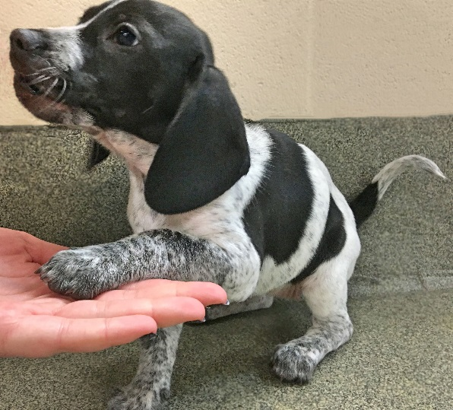
Objective:
Our goal for this program is to help the dogs learn basic manners and polish their social skills to make them more appealing to potential adopters and to shorten their length of stay in the shelter.

Dogs in the Program:
Dogs that could most benefit from additional training will be listed on the training board along with the skills that should be focused on. This board will list assignments and provide an area to initial once dogs are worked with. Training sessions should be kept short. About 15 minutes per dog is ideal. Watch for signs that the dog is becoming bored or frustrated and end the training session as appropriate. If all dogs on the board have been worked with during your shift, you may choose other dogs from the kennel to work with.

Training Overview

Why positive reinforcement?
A positive approach can teach a dog to love learning. It is much easier to train a willing participant. Shelter dogs have stressful lives; we are here to make their human interactions pleasant and enriching. Positive reinforcement training utilizes treats and praise to reward desired results. Undesired results are ignored rather than punished. Never raise your voice in frustration or physically punish an uncooperative dog.
What is environmentally cued training?
Dogs can be conditioned to offer a desired behavior immediately upon receiving a cue from the environment. As an example, the dogs are conditioned to sit before they are allowed to walk through any door. The door eventually becomes the cue for the dog to sit and wait to be given permission to enter or exit. A verbal command is no longer needed. Environmentally cued results will come over time if consistency in training is used.
What is capturing?
Capturing is a method of training that rewards a dog for performing a desired behavior when no command was given. For example, you walk past a kennel and a dog walks to the front of the cage and sits quietly. The dog is rewarded as if they had responded to a command with a “Yes!” and a treat. This reinforces the behavior so the dog will be more likely to perform the desired behavior in the future.
Improving Success Rates:
You must provide consistent input and handling to help the dogs learn what the expected behavior is. Dogs will continue to test their handlers if situations are not handled in the same manner by all. This is why it is important that all handlers are following the training guidelines at all times. It is also important to provide the reward (treats or praise) immediately after the desired behavior is displayed (within one second) so the dog learns the connection between the behavior and the reward. It is just as important to avoid inadvertently rewarding negative behavior. Never pet a shelter dog or provide treats or praise if they are performing an undesirable behavior such as jumping up or barking.
Teaching Commands:
- If a dog does not know a command, start training using hand signals only.
- Once the dog is responding to the hand signal at least 90% of the time introduce the verbal command along with the hand signal.
- Use a command one time only. Do not say “Sit, Sit, Sit, Sit, SIT!”
- Once the dog is reliably responding to the hand signal with verbal command, phase out the use of the hand signal until the dog responds to just the verbal command.
- Once the dog responds to both the verbal command and hand signal separately, vary between both so that the dog will respond to either the verbal or non-verbal commands.
- When utilizing verbal commands, be aware of your voice. Dogs respond to tone of voice as much as they do the actual words you are saying. Use a firm, calm voice but refrain from yelling orders at the dog or speaking too softly. Do not phrase the command as a question. Say “Sit!” not “Sit?”

Teach a reward marker: “YES!”
A bridge or marker is a sound that lets the dog know that the behavior just presented to you is exactly what you are looking for. A marker word is usually followed immediately by a yummy treat. To insure consistency, we use “Yes!” as the marker for all the Shelter Dogs. You can teach the dog the meaning of a marker by doing the following: Have a pocket full of small, tasty treats. Find a quiet area where the dog will not be easily distracted. Be close enough to the dog to hand him a treat within one second. Do not ask the dog to perform any behavior. Simply say “yes!” and give the dog a treat. Repeat this sequence with the dog in all different positions (sitting, standing, lying down) and in lots of different locations (in the kennel, in the training room, outside). Do this 20-25 times a day for a few days and the dog will quickly learn that he wants to do whatever it takes to get you to say “yes!”.

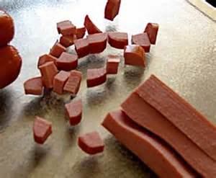
What should we use for treats?
You need to choose something desirable enough to compete with the distractions of other dogs, people, and excitement. Soft treats with a strong odor work best. Most dogs will happily respond to pieces of Beggin’ Strips or commercial training treats. Dogs that do not respond to regular treats may need something of higher value such as freeze-dried liver, diced up hot dogs, or bits of cheese.
Treats need to be broken into tiny pieces, smaller than the size of a pea. This will allow you to dole out 50-100 treats in a session without causing the dog to have stomach upset.
If a dog is on a special diet, they will not be able to have treats. Their kibble can be used as their reward.

Teach a Release Word: “Okay!”
A release word is a word or phrase that lets the dog know they are done performing a command. For consistency, we will use “Okay!” to release the dogs. Once dogs know a basic command, such as sit, or lay down, you can build in an implied “stay.” The dog will learn not to move from the sit or down position until they are given the release word.

Patience:

When training dogs, patience is key. If you are beginning to feel anxious or frustrated it is time to end the training session. Some dogs learn faster than others. One dog may pick up a command in a single training session, while another dog takes multiple lessons to learn a basic command. Once a dog learns a command you must continue to practice that skill to reinforce it. Do not rush to add a verbal command or drop a hand signal until the dog is reliably performing the desired behavior.

Teach a Dog to Look:
The Look command is useful in getting a dog’s attention and is a great command to start training with. This is an especially useful command for dogs that are easily distracted by their environment such as other dogs, people, etc.
The hand signal is an index finger between your eyes.
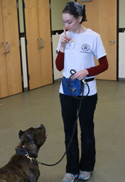
- In a quiet area, hold a yummy treat between your thumb and index finger.
- While standing up straight, place the treat near the dog’s nose and move it up to your face such that your index finger is positioned between your eyes.
- As soon as the dog makes eye contact, say “Yes!” and give them the treat.
- Repeat, repeat, repeat.
- Once the dog has learned to quickly look at you, add in the verbal command “Look” while giving the hand signal.
- As the dog gets faster at following your finger, you can gradually stop starting with the treat in front of their nose.
- Once the dog is reliably responding to the verbal command/hand signal combo, phase out the use of the hand signal.
- Once the dog is responding to just the verbal command, vary between using the verbal command and hand signal so the dog is responding to both the verbal and non-verbal command.

Troubleshooting:
If the dog is not picking this up quickly, try switching to a higher-value treat such as pieces of cheese or hot dogs or move to a less distracting environment.

Advanced:
Once the dog is responding to both the verbal and non-verbal command for Look begin practicing in more distracting locations such as around other dogs or people.

Teach a Dog to Sit:
Sit is relatively easy to teach and another great command to work on when starting basic training. Many other commands can be added once a dog knows how to sit reliably.
The hand signal is an open palm toward the sky, bending your elbow at the waist over the dog’s head.
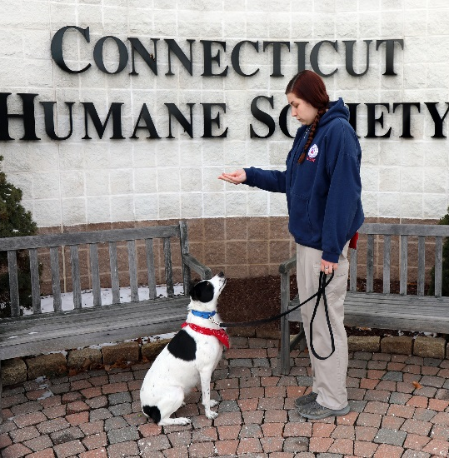
- Find a quiet area with no distractions.
- Hold a highly desirable treat between your thumb and pointer finger.
- Make sure the dog has all four paws on the floor.
- With your palm facing upward in front of the dog’s nose, slowly raise the treat up above their head.
- As the treat rises over their head, the dog will naturally look up to follow it. This will force them into a sit.
- When the dog’s rump hits the floor, immediately say “Yes!” and reward them with the treat.
- Repeat, repeat, repeat. As the dog starts to learn what you are asking of him, he will sit for the treat faster and faster.
- Once the dog is sitting for the raised treat 90% of the time, introduce the command, “Sit” while using the hand signal. Continue to say “Yes!” and reward with a treat when the dog sits.
- Once the dog is reliably responding to the hand signal/verbal command, remove the hand signal and use the spoken command only. Continue to say “Yes!” and reward with a treat when the dog sits.
- Once the dog reliably responds to the verbal command on its own, vary between using the hand signal or verbal command so that the dog responds to both the verbal and non-verbal command. Continue to say “Yes!” when the dog sits but vary how often you reward with a treat.
- When weaning the dog off of treats, mix it up. First offer a treat every other time they sit, then after sitting three or four times in a row, then back to every sit. This way the dog never knows when to expect a treat and will work for it every time.
Troubleshooting:
If the dog backs away from the treat rather than looking up at it, move the dog into a corner. This will force him to move his head up (and his rump down) to follow the treat as it rises over his head. Never forcibly push the dog into a sit.
Advanced:
Once the dog is sitting reliably for both a hand signal or verbal command, you will want to introduce an implied “stay.” To do this, take the dog to a quiet area, ask the dog to sit, say “Yes!” immediately when they sit, then give multiple treats while they continue to stay seated. Then use your release command, “Okay!” and walk away holding the leash, causing the dog to stand back up. Continue to increase the amount of time they stay sitting by using multiple treats and increasing the amount of time in between feeding each treat. Always release the dog with “Okay!” This will teach the dog that when they sit they are to stay in that position until released.
Expert:
Once the dog has learned to stay sitting until given the “Okay!” command, practice the sit with implied stay in more distracting environments. You can create your own distractions by asking the dog to “sit” then doing things like running in place, jumping jacks, turning your back to the dog, etc. If the dog stays seated, reward with a treat then release with “Okay!” If they do not stay sitting say “Nope” and do not treat.

Teach a Dog to Lie Down:
Down is a command that is best taught once a dog already has a solid grip on the Sit command.
The hand signal is an open palm facing down starting at the waist and lowering toward the ground.
- In a quiet area, put the dog into a sitting position.
- Hold a yummy treat between the palm and thumb of your hand and with your palm facing downward slowly move the treat from the dog’s nose, down to the ground between their front paws.
- Once the treat is there be patient; it may take a few seconds for the dog to realize that it would be more comfortable to eat lying down.
- As soon as the dog is in the down position say “Yes!” and allow them to eat the treat.
- Repeat, repeat, repeat.
- Once the dog is reliably lying down to eat the treat, introduce the “Down” command.
- Once the dog is responding to the combination of the hand signal and command, use just the verbal command without the hand signal.
- Once the dog is responding to both the hand signal and verbal signals separately, vary between both so the dog responds to both the verbal and non-verbal command.
Troubleshooting:
If the dog does not lie down, try moving the treat between their paws closer toward them, almost so it is under their body. This will usually force them to have to lie down to follow the treat.
If that doesn’t work, try capturing the down behavior. For this you would simply wait until you see the dog lie down, then say “Yes!” treat the behavior then follow with praise.
Advanced:
Once the dog is reliably lying down for both the verbal command hand signal you will want to build in an implied stay. To do this, take the dog to a quiet area, put the dog in the down position, say “Yes!” immediately then give multiple treats while they continue to stay down. Then use your release command, “Okay!” and walk away holding the leash, causing the dog to stand back up. Continue to increase the amount of time they stay down by using multiple treats and increasing the amount of time in between feeding each treat. Always release the dog with “Okay!” This will teach the dog that when they lie down they are to stay in that position until released.
Expert:
Once the dog has learned to stay down until given the “Okay!” command, practice down with the implied stay in more distracting environments. You can create your own distraction by putting the dog into a down position then doing things like running in place, jumping jacks, turning your back to the dog, etc. If the dog stays down, reward with a treat then release with “Okay!” If they do not stay down say “Nope” and do not treat. You can also start giving the “down” command without asking the dog to sit first. Once a dog knows what “down” means they will start lying down straight from a standing position.
Teach a Dog to Come:
Teaching a dog to come when called may prove to be the most important exercise that you ever do with the dog. If the dog ever gets loose, a “Come” command may be the difference between a tragedy and a happy reunion.
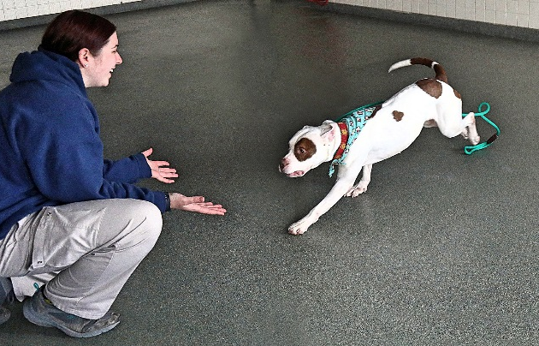
The hand signal for come is extending your arm then bringing your hand toward your chest.
- Take the dog to an empty room or fenced-in area that is free from distraction and drop the leash.
- Walk away from the dog then using the dog’s name call “Max, Come!” in a loud, happy voice while giving the hand signal.
- As soon as the dog starts moving towards you say “Yes!” and once the dog reaches you immediately take them by the leash or collar and give a bunch of small yummy treats then say “Okay!”
- Repeat, repeat, repeat.

Troubleshooting:
If the dog starts to follow you around and you are not able to increase your distance from the dog, have a second handler hold the dog, then release the leash when you call “Max, Come!”
If the dog does not respond when called, you may need to use a higher-value treat such as pieces of cheese or hot dog. Also be aware of the tone of your voice. The key is to sound happy, not angry! You can also try kneeling down as you call “Come!”
Advanced:
Once the dog is reliably coming when called, practice in an area with more distractions such as other people or animals. The use of a long-lead is especially useful if you are working outside. You can also drop the verbal command and practice using just the hand signal. This is helpful if the dog is ever out of ear-shot.
The “Come” Game:
If playing alone, ask the dog to sit and stay, then walk away. Call “Max, Come!” As the dog starts running towards you say “Yes!” When they reach you, grab their leash or collar then reward with lots of yummy treats and praise. Repeat.
If playing with two handlers, stand opposite from each other and take turns calling the dog back and forth. Always reward with lots of yummy treats or praise.

Teach a Dog to Leave It:
Having a dog that is able to leave anything on command can save a dog’s life. LEAVE IT can be applied to anything that the dog is focusing on.
There is no hand signal for this command. A dog needs to be able to respond to the verbal cue immediately.
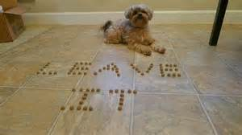
- In a quiet area, put a pile of smelly treats in your hand.
- Make a fist with the treats in your hand and place it on the ground while saying “Leave It!”
- The dog will naturally show interest in your fist, possibly even paw at it or lick it. Never feed the dog from the treats in this hand. Leave it means forever!
- When the dog gets frustrated and looks away say “Yes!” and give a treat from your opposite hand.
- Continue this exercise until the dog looks away immediately when you say “Leave It!”

Troubleshooting:
If your dog is having difficulty picking this up, use a low-value treat in your fist (such as a hard Milkbone) and reward with a higher-value treat such as cheese or hot dogs.
Always say “Yes!” as soon as the dog looks away from the fist and follow with the yummy reward within a second.
When saying “Leave It!” it helps to use a voice that sounds firm and authoritative.

Advanced:
Now that the dog is immediately looking away from the fist upon the command “Leave It!” continue this exercise by tossing the treat to the ground. Start by tossing the treat at a distance from the dog with the dog on leash so that he cannot reach the treat then gradually toss the treat closer and closer to the dog. Never allow the dog to eat the treat he is being asked to “leave.” Continue to reward the dog with a mix of treats and praise.

Expert:
Once your dog is at a point where they are able to “leave it” when a treat is tossed right next to them on the ground, put the dog into a Sit and Stay then toss a treat on the ground and say “Leave It!” then slowly back away from the dog. Return to the dog, say “Yes!” and reward with yummy treats or praise. Gradually increase the distance between you and the dog. Eventually you should be able to leave the room while the dog continues to sit and ignore the treat on the ground.
Teach a Dog to Stay:
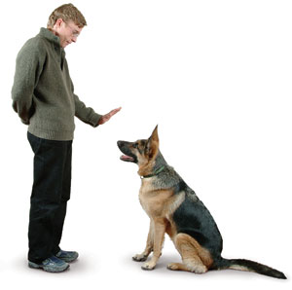
Stay is a command that can be introduced once a dog knows how to reliably sit. Stay is a great tool for teaching dogs patience.
The hand signal is an open palm in the dog’s face.
- Find a quiet area with no distractions.
- Ask the dog to sit. Say “Yes!” and reward with a treat.
- Give the dog the hand signal for “stay.”
- Continuously feed tiny treats to the dog for a couple of seconds as they stay seated.
- Say “Okay!” then walk away, using the leash to lure the dog back into a standing position.
- As you continue to practice, increase the amount of time you are keeping the dog in the stay position by increasing the number of treats given, and gradually start to space out how quickly they receive each treat. Continue to say “Okay!” and bring the dog back to a standing position each time you finish.
- Once the dog is reliably staying, introduce the verbal command “Stay” while using the hand signal.
- Once the dog is reliably staying for both the verbal command/hand signal, use just the verbal command without the hand signal.
- Once the dog responds to both the verbal command and hand signal separately, vary your use of each so that the dog responds to both the verbal and non-verbal command.
- As you continue to practice this command, vary how long you keep the dog in the stay position and vary how often they are rewarded. Always use your release command, “Okay!” to release the dog from the stay position.
Troubleshooting:
If the dog does not stay seated say “nope” and do not give any treats. Start over, this time making sure to feed the treats in quicker secession.
Advanced:
Now that the dog is reliably responding to both the hand signal and verbal command for “Stay” and is able to hold it until released you can begin to work on increasing the distance between you and the dog. Take the dog to a quiet area, ask the dog to sit, give the command “Stay” then take a step backwards. Step back towards the dog and give a treat, then release the dog with “Okay!” Continue to practice this, gradually increasing how far you back away from the dog. When practicing this outside, never drop the leash. Use a long lead if necessary. Always release the dog when done. Once the dog is reliably staying while you walk away, vary the reward between treats and praise only.
Expert:
Now that the dog is reliably holding a stay when you walk away, practice in an environment with more distractions such as other people or animals. You can create your own distractions by asking the dog to stay then jogging in place, doing jumping jacks, or walking in a circle around the dog. Continue to reward with either treats or praise and always release with “Okay!” You can also practice putting the dog into a stay then turning your back on the dog and walking away, gradually increasing the distance. Eventually you should be able to walk into another room while the dog stays seated until you return and give the release command.
Incorporating Games into Your Training Session:
In addition to teaching the dogs some basic skills during your training shift, feel free to have some fun by playing some training games with them.
Using the A-Frame
- Using a yummy treat as a lure, lead your dog on their leash up and over the A-Frame and down the other side.
- Use the command “up up!” while they are going over the equipment.
- When they get down the other side say “Yes!” and reward with the treat.
- Repeat, repeat, repeat.
- Once the dog is comfortable going over the A-Frame, drop the leash and repeat the exercise.
Troubleshooting: If the dog is hesitant to go over, adjust the frame until it is laying completely on the ground. Have the dog go over and reward as you normally would. Slowly increase the frame height until the dog can go over at normal height.
The A-Frame is not for all dogs. Never force a dog that is timid.
Hand Targeting
- Hold out an open hand in front of your dog about two inches away from his nose.
- Your dog will likely move forward to sniff your hand. The instant you feel his nose touch your palm say “Yes!” and reward with a treat.
- Repeat, repeat, repeat.
- Once your dog is reliably touching his nose to your palm, add in the command “Touch!” when offering your palm.
- Repeat the exercise, gradually moving your palm further and further away from the dog’s nose. Never move your hand to the dog, always wait for the dog’s nose to come to you.
- Once the dog is reliably touching his nose to your palm upon command, start moving your hand into different positions: a little to the right, a little to the left, above his head, down low, between your legs. Always have your palm facing the dog. Continue to reward each Touch with “Yes!” and treats or praise.
Troubleshooting:
If your dog doesn’t seem interested in touching his nose to your hand, try a higher-value treat such as pieces of cheese or hot dog. You can rub the treat into your palm to make it smell more interesting.

Training Assignments:
The training board will be utilized to communicate which dogs are most in need of additional training and which exercises we would like you to focus on.
The following abbreviations will be utilized on the training board:
OB1= Obedience 1
Obedience 1 commands include Look, Sit and Down.
OB2= Obedience 2
Obedience 2 commands include Come, Leave-It and Stay.
QT= Quiet Time
This dog could benefit from some quiet time. Take them to a quiet room and read them a book or brush
them.
EX= Exercise
This dog could benefit from some good aerobic exercise. Take them to the pen and let them run or play
a game of fetch. If you’re a runner, take them on a short jog around the property. If the dog becomes
over-stimulated while jogging bring them back inside and let the Behavior Coordinator know.
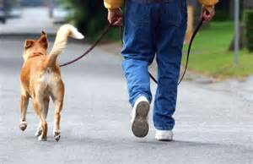
LLW= Loose-Leash Walking
This dog needs to learn some leash manners! Refer to your Purple Dog Walker packet for tips on
practicing loose-leash walking.

Summary
The time that you spend working with the shelter dogs will have an impact on how quickly they are adopted and how quickly they settle into their new home. A well-behaved dog is less likely to be returned to the shelter. Additionally, training sessions provide mental stimulation for the dogs during their stay at the shelter. Mental stimulation is important for decreasing depression and boredom and the negative behaviors that can result.
Although you may only spend a short time with each dog, the cumulative effect of the training team as a whole will have a lasting impact on their well-being. You are making a difference!

