How To Clicker Train
a Cat
2018 Edition

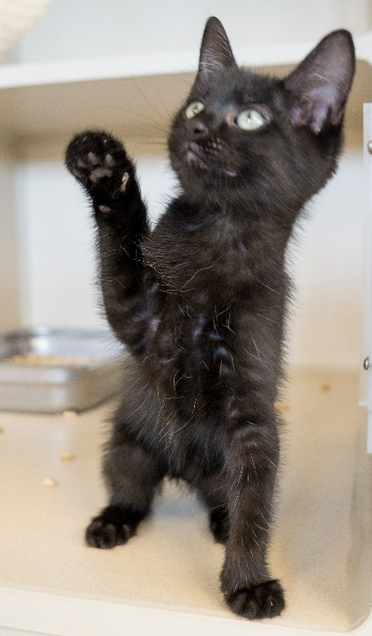
Objective:
Our goal for this program is to provide enrichment for the cats during their stay. Mental stimulation reduces their stress level which in turn lowers their risk for becoming sick. And clicker training is a fun way for volunteers to engage with the cats. Any cat in an authorized area may receive clicker training. If a cat is labeled “Fur Squad” or “Staff Only” they may receive hands-off training with the cage door closed.

Training Overview
Cats can be trained?!
Yes! Although cats have a reputation for doing things on their own terms, they can be trained. Just google “cat agility” to see some examples of cats who have mastered training.
What is clicker training?
A clicker makes a very distinct sound. When teaching a skill, the trainer will “click” and then immediately follow it with a treat. Cats quickly learn that “click” = yummy treat and will want to do whatever it takes to get the “click.” An initial skill in clicker training is teaching a cat to touch a target. Once the cat has learned to touch the target, the target can be used as a lure to teach the cat more advanced skills such as sitting, giving a high-five, jumping through a hoop or circling.
Improving Success Rates:
With clicker training, timing is everything! You must remember to click as soon as the cat does the desired behavior, then immediately (within one second) follow it with a treat. Also, make sure the clicker you are using does not frighten the cat. Some are louder than others. When working with cats, a softer clicker is preferred.
What should we use for treats?
You must find a treat that the cat will respond to. At CHS, we always start by using their kibble as the reward. If they aren’t interested in the kibble, we move on to higher-value rewards, such as small crunchy or soft cat treats. A picky eater may require small pieces of tuna from a can, or a lick-able treat pouch.
Treats need to be broken into tiny pieces, smaller than the size of a pea. This will allow you to dole out multiple treats in a session without causing the cat to have stomach upset. Do not feed a cat more than 1/8 cup of food (2 tablespoons) during a training session.
If a cat is on a special diet, they will not be able to have treats. Their kibble or prescription canned food can be used as their reward.
Charging the Clicker:
The distinct sound of the clicker serves as a marker: it lets the cat know that the behavior just presented to you is exactly what you are looking for. You can teach the cat the meaning of a marker by doing the following: Simply click, then immediately follow it with a treat. Do not ask the cat to perform any behavior. Just click then give them a treat. Repeat this a few times and the cat will quickly learn that the click means a reward is coming.
Teaching Tips:
- Once the clicker is charged, begin by teaching them to approach and touch a target.
- Once they are reliably touching the target on command, use the target as a lure to teach more advanced skills.
- Once a cat is reliably responding to a command, introduce a verbal cue and start to wean them off the treat by only offering the treat randomly as a reward.
- Use a verbal cue one time only. Do not say “Sit, Sit, Sit, Sit, SIT!”
- Patience is key! Some cats learn faster than others.

Teach a Cat to Approach:
Teaching a cat to approach people will help them get adopted faster. A cat who initiates an interaction with a potential adopter will appear much more appealing than a cat who sits in a corner, disinterested. This training is especially important for cats who are under-socialized.
- Approach the cage and quietly call the cat by their name while showing them a treat.
- If the cat moves toward you, click, then immediately offer them the treat.
- If the cat doesn’t move toward you, call their name then wait until they look at you to click and toss them a treat.
- Continue to click and reward them for looking at you when called, but gradually move the treat closer to the front of the cage so that they must get up to get the treat.
- Once the cat is reliably approaching when called, start to phase out the treat as a reward by only offering it randomly and use petting as an alternate reward.

Advanced: Working with Under-socialized and Fearful Cats
- Approach the cage while calling their name softly. Click and toss the treat as near as you can to the cat, then step back quickly. If the cat eats the treat, continue. If not, try again later.
- Repeat step one a few times.
- Gradually place the treat closer and closer to the front of the cage. Always click prior to offering the treat and continue to take a step back after you deposit the treat.
- Once the cat becomes comfortable approaching the front of the cage for the treat, stand there quietly without backing away while they eat the treat.
- When the cat begins to approach the front of the cage on their own, click and give them a treat.

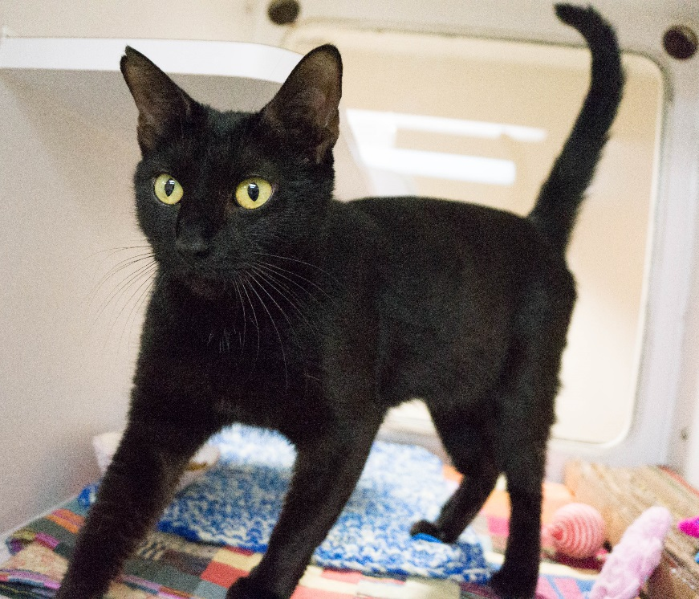

Teach a Cat to Touch a Target:
Teaching a cat to touch a target with their nose is necessary for teaching more advanced tricks. Teaching a cat to touch a target is relatively easy.
- Show the cat a target such as a tongue depressor.
- When they move towards the target, click then immediately offer a reward.
- Next, click only when they touch the target with their nose, then immediately offer a reward.
- Take a break after 4-5 clicks and put the target away.
- A few minutes later, bring the target out and resume clicking when they touch it followed by a reward.
- As the cat approaches the target, move the target away from them so they have to step towards it to touch it. When they touch it with their nose, click and immediately offer a reward.
- Once the cat seems to be intentionally touching their nose to the target, introduce the verbal cue, “touch.”

Troubleshooting:
If the cat is not interested in the target at first, try rubbing something on it, like a little bit of canned food, to get them interested in it.

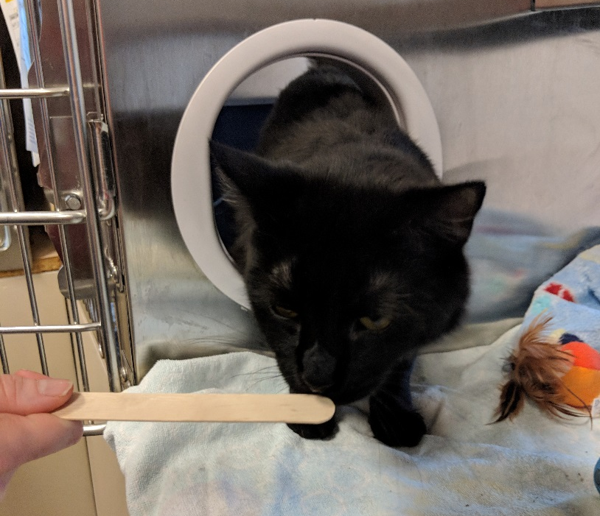

Teach a Cat to Sit:
There are two ways to teach a cat to sit. One is by using a target to lure them into position. The other is by “capturing” the behavior when they sit on their own.
- Once your cat is touching the target consistently, place the target in front of their face then slowly move it over their head.
- As they look up towards the target and start to move their rear end toward the ground, click then immediately follow with a reward. You can place food on the target to use it as a lure.
- When the cat sits, click and immediately offer a reward.
- When the cat begins offering this behavior reliably, add in the verbal cue, “sit.”
- Remove the target, give the verbal cue, then only click and reward once the cat sits.
Another way to teach “sit” is to wait until the cat sits on their own, without being cued. As soon as they sit, click and offer a reward. This is called “capturing.”
Troubleshooting:
If the cat jumps up instead of sitting, try lowering the target.

Teach a Cat to Give a High-Five:
High-fives are a fun trick to teach a cat and make a big impression on anybody who meets the cat.
- Once the cat is consistently touching the target, hold the target over their head, out of reach from their nose. You can place a treat on the target.
- When the cat reaches up with their paw to bring the target closer, click and immediately follow it with a reward.
- Repeat steps 1 and 2, gradually moving your hand down the target, closer to the tip.
- When the cat is reliably touching the target with their paw, remove the target and just put out your hand for them to touch. Click and immediately follow it with a reward every time they reach out to touch your hand.
- Once the cat is reliably giving a high-five, introduce the verbal cue, “high-five.”

Teach a Cat to Go to a Mat:
Teaching a cat to go to a mat isn’t just a fun trick- it can be useful if you need to get a cat to go into a carrier or stand on a scale at the vet. Once a cat is consistently responding to the target this is a fast skill to teach.
- Designate a blanket or towel as your “mat.”
- Hold the target over the blanket.
- As soon as the cat begins to approach the target, click and immediately offer them a reward.
- When the cat steps on the mat, click and immediately offer a reward.
- Once the cat is reliably moving to the mat on their own, introduce the verbal cue, “go to your mat.”
- Remove the target, give the verbal cue, then only click and reward once the cat goes and steps on the mat.

Recording Progress:
Please record your progress on the cat’s clicker training chart. If the cat does not already have a chart attached to their paperwork, please begin one. Begin with the Clicker 1 assignments (approaching and touching the target). Do not move on to the Clicker 2 assignments until the cat is reliably responding to the Clicker 1 cues.
When recording progress, give the cat a 1 if they are consistently responding to the cue, a 2 if they respond sometimes, and a 3 if they never respond to it.

Summary
Your efforts with the cats will help improve their mental well-being during their stay at CHS. Mental stimulation is important for decreasing depression and boredom and the negative behaviors that can result.
Although you may only spend a short time with each cat, the cumulative effect of the clicker training team will have a lasting impact on their well-being. You are making a difference!

