Mod Squad
Training Manual
____________________________________
2016 Edition

Forward

Some of the shelter dogs display behaviors that make them undesirable to adopters. Dogs that lunge or bark when approached, aggress towards other dogs, cower at the back of the cage, or become overly excited during play may be overlooked and take longer to adopt. These dogs aren’t bad, they’re complicated! They just need to overcome a few issues to make them more desirable.
Behavior modification techniques can be used to help these dogs overcome their issues so we can successfully place them in loving, forever homes.
When working with the dogs, consistency is key! Please closely follow the modification protocols in this manual when working with MOD SQUAD dogs.

Note: The behavior staff has assessed the dogs and those that could most benefit from behavior modification will be listed on the training board along with the skills that should be focused on. It is not your job to assess the severity of their issues or to push the dogs to illicit a negative response. If the dog is not demonstrating the problem behavior it is a sign that they are making progress. Please do not undo their progress just to see the problem with your own eyes.

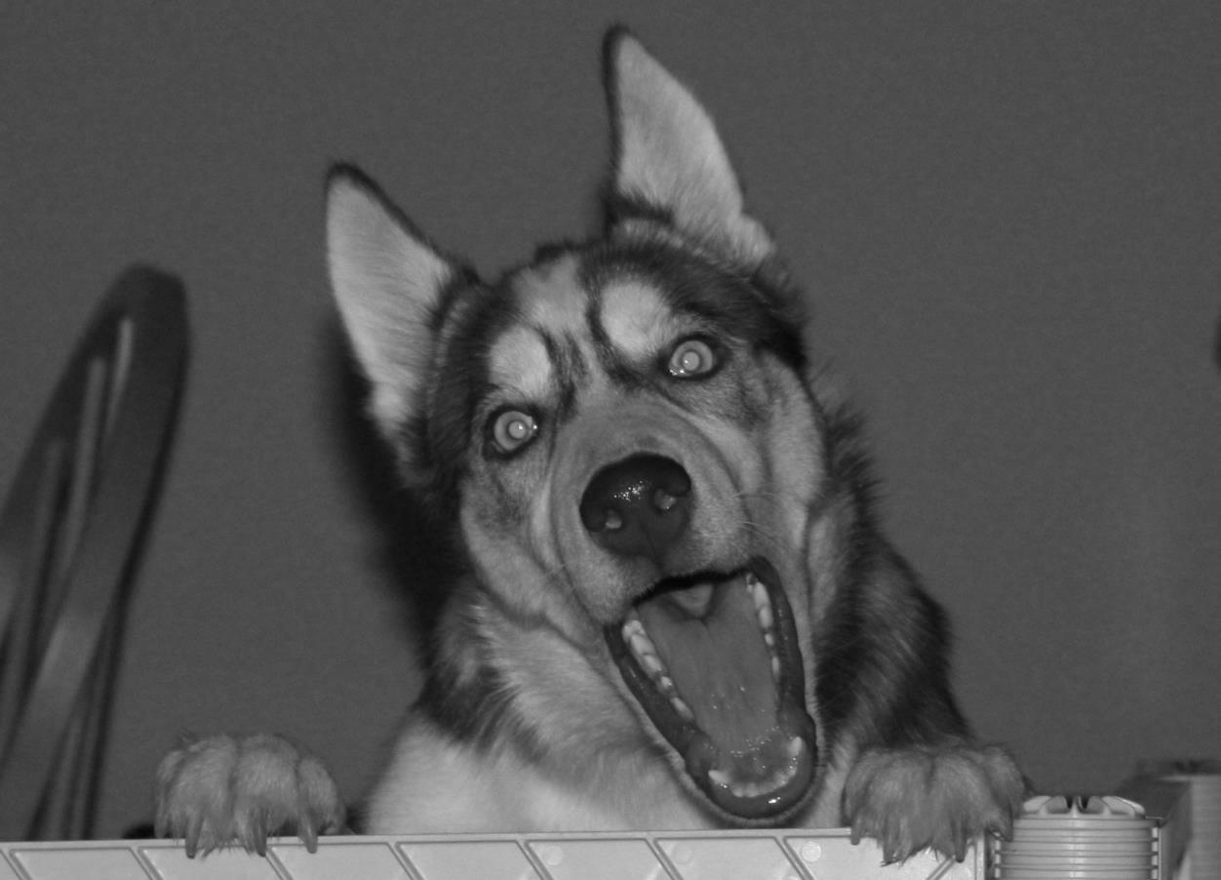

Behavior Modification Protocol
Barrier Aggression

General Description: This is the program we use to modify the behavior of dogs that bark aggressively or lunge when people approach them in their kennel. The goal of this program is to decrease aggression behind the kennel door and to condition them to sit quietly when approached in their kennel.

Program Instructions:

1. In a quiet location free from distraction, teach the dog the “sit” cue.

2. Once the dog is reliably responding to “sit” you can begin working with them in the kennel.

3. Approach the front of the kennel in a non-threatening manner (turned to the side and without making direct eye contact), while holding out a treat towards the dog.

4. If the dog approaches you calmly (no barking, lunging or jumping) say “yes!” and immediately toss them the treat through the bars.

5. If the dog displays any negative behaviors, say “nope” and turn your back to the dog and walk away. Approach the kennel and begin again.

6. Once the dog is reliably approaching the front of the kennel calmly when you approach, you can introduce the “sit” cue. If the dog sits, say “yes!” and immediately toss them the treat through the bars.

7. If the dog doesn’t sit, say “nope” and turn your back to the dog and walk away. Approach the kennel and begin again.

8. Continue practicing this protocol until the dog reliably approaches the front of the kennel and sits when approached. Over time the dog will be conditioned to do this without needing a verbal cue or hand signal.

Note: If working with a Staff-Only dog, skip steps 1 and 2.

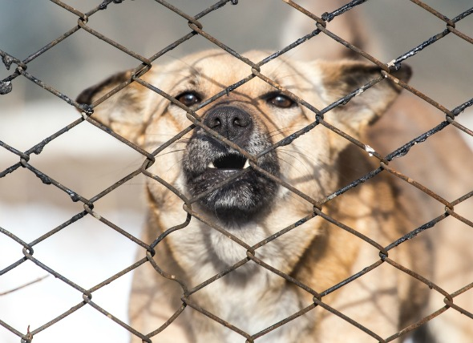

Behavior Modification Protocol
Reactivity towards Other Dogs

General Description: This is the program we use to modify the behavior of the shelter dogs that are reactive or leash aggressive toward other dogs. The goal is to be able to walk calmly around other leashed dogs at a distance without aggressive displays.

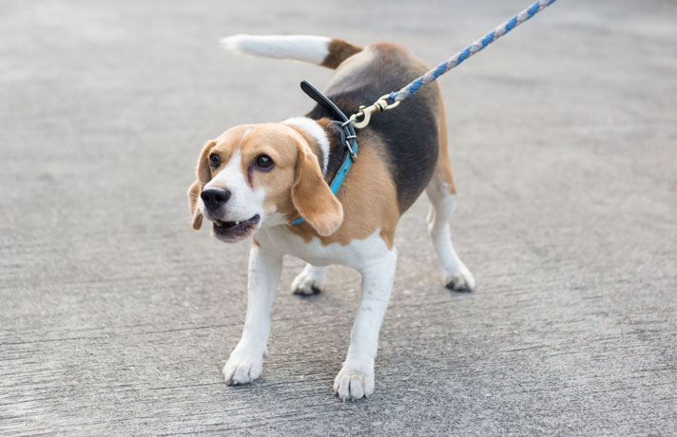
Program instructions:

1. Teach the dog a “look” cue. The goal of using this cue is to have the dog turn and make eye contact with you when you say the verbal cue.

2. Teach the dog the “sit” cue.

3. Now that the dog knows how to both “look” and “sit,” bring the reactive dog to an area where they can see other dogs. For example, walk them towards the outside play yard while another dog is in the fenced-in area playing. Stay far enough away so that the dog can see the other dog but is not reacting aggressively. If the dog starts reacting aggressively you have gotten too close. The dog should be showing little to no reactivity before moving on to the next step.

4. Practice the “look” and “sit” cue. Remember to use your marker word immediately once the dog responds to either cue, and within one second reward with lots of yummy treats.

5. Once the dog is successful at a certain distance, decrease the distance between the two dogs and repeat the above procedure.

6. Continue to decrease the distance according to the dog’s success and repeat the above procedure.

Notes:
Be mindful of thresholds. This means don’t overestimate the dog’s ability to remain composed and focused. Always try to set the dog up for success by not walking the dog in congested areas or near another dog walker.
Watch the dog for signs that they are reaching their threshold, such as staring hard at the other dog, moving their body weight onto their front feet, piloerection (hair standing on end). If you see these signs you are too close.

If you come upon a dog you were not prepared for, tell your dog “Let’s Go” and quickly walk in the opposite direction. Praise and treat once the dog recovers and refocuses on you.

DO NOT jerk the leash, yell at, or grab an agitated dog. Stay calm and use steady pressure to remove the dog with a leash.

Behavior Modification Protocol
Building Confidence in Shy/Fearful Dogs

General Description: This is the program we use to build confidence in non-aggressive dogs that are acting shy or fearful in the shelter environment. The goal is to help them become more comfortable in the kennel environment and for them to willingly come to the front of the kennel for interaction.
Program Instructions:
1. Approach the front of the kennel in a non-threatening manner (turned to the side and without making eye contact). Kneel on the ground with one knee up to make yourself look smaller and less intimidating.
2. In a soft, happy voice, call the dog to you by their name and show them a yummy treat in your hand.
3. If the dog moves closer to you, say “yes!” and toss a treat towards them.
4. If the dog moves away from you or doesn’t approach, continue to kneel patiently outside the kennel. Any time they take a step towards you, say “yes!” and toss a treat towards them.
5. As the dog becomes more confident, toss the treats closer and closer to the front of the kennel.
6. Continue practicing with this method until the dog approaches the front of the kennel willingly.
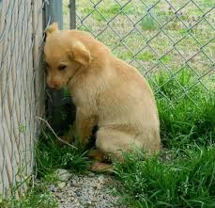
Note: Always go slow and be patient.
Additional Method:
1. Take the dog and a book into a quiet room or enclosure.
2. Have a seat (on a bench or chair, not on the floor) and softly read aloud while ignoring the dog.
3. If the dog approaches, say “yes!” and toss a treat to them.
4. If the dog gets close enough to touch, put some treats in the palm of your hand and slowly hold it out for them to take the treats out of your hand. While the dog is eating out of your hand, use your other hand to gently pet them under the chin.
Note: Patience is the key! Never force the dog to be touched. Only do so if they approach willingly and are comfortable with it. If they move away from your touch, do not force it. Watch for signs that the dog is uncomfortable such as a tucked tail, lip licking, ears pinned back or avoidance.
If the dog does not want to exit the kennel, use treats to lure them out. If the dog won’t walk on the leash, DO NOT drag them. Use treats to try to lure them forward.

Behavior Modification Protocol
Inappropriate Play Program

General Description: This is the program we use when a dog gets overstimulated during play and starts jumping up, growling or becoming mouthy. A “time out” is used to teach the dog that play will end when they become inappropriate. The goal of this program is for the dog to play in a less physical and more appropriate manner with humans.

Program Instructions:
1. Take the dog to the fenced outside play area and drop the leash.
2. Engage the dog in a polite (not rough and tumble) game of chase.
3. The moment the dog becomes inappropriate (jumping on you, moderately mouthing, mounting, or body slamming) say “nope” in a firm (not angry) tone then lead them by the leash into the catch pen, closing them in by themselves for a “time out.”

4. Do not give any attention to the dog during the “time out.” Turn your back to them and do not speak to them.

5. Wait one or two minutes for the dog to settle down, then open the door to the catch-pen and let the dog re-engage in play with you.

6. Repeat the sequence for 10–20 minutes.

Note: If the dog becomes increasingly inappropriate (hard mouthing, obsessive mounting, etc.) lead them to the catch-pen for a final “time out” to allow them to calm down, then return them to the kennel. If you feel that you are unable to control the dog, use your walkie talkie to call for assistance.
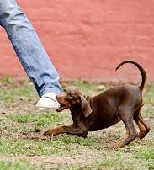
Since the reward for the dog in this program is play, you do not need to use treats as a reward.

If the outdoor play area is not equipped with a catch-pen, use a large crate inside the pen as your “time out” area.

Additional Training
Mat Work
General Description: Teaching a dog to “go to mat” is a useful tool for dogs that can get overly excited. For example, a dog that jumps on visitors that enter the house can be trained to “go to mat” and wait patiently until they are allowed to calmly approach. We can teach the basics of mat work while the dog is in the shelter. Just like a crate, the mat should never be used as a punishment. Instead, it should be a happy place that the dog will willingly go to.
Program Instructions:
1. Take the dog to a quiet room and place a comfortable mat on the ground.
2. Stand 1-2 feet away from the mat and toss a treat onto the mat while saying “Go to mat!” and pointing towards it.
3. When the dog steps onto the mat say “yes!” and continue to toss yummy treats onto the mat for a few seconds.
4. Say “Okay!” and stop throwing treats. The dog will likely leave the mat.
5. Repeat, repeat, repeat.
6. Gradually increase the distance between yourself and the mat. Continue to toss a treat onto it while saying “Go to mat!” Always say “yes!” immediately when the dog steps onto the mat and follow up with a series of treats, increasing the amount of time between each treat you toss. Always end with “Okay!”
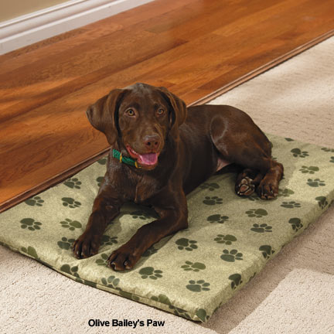
7. Say “Go to mat!” and point to it but do not throw a treat. When the dog goes to the mat immediately say “yes!” and toss a bunch of treats onto the mat.
8. Repeat, repeat, repeat.
9. Now that the dog is going to the mat on command, you can start linking other commands. Say “Go to mat!” and say “yes!” when the dog steps onto the mat. Then give the dog the command for “sit” or “down.” Say “yes!” when they follow the command and follow with lots of yummy treats. Always end with “Okay!”

Behavior Modification Assignments:
The training board will be utilized to communicate which dogs are most in need of behavior modification and which exercises we would like you to focus on.
The following abbreviations will be utilized on the training board:
BA- Barrier Aggression
DR- Dog Reactivity
SD- Shy Dog
IP- Inappropriate Play
MW- Mat Work

Summary
Thank you for taking the time to help the shelter dogs overcome their fears and learn new manners. The time you spend teaching them confidence and self-control will certainly help them not only to get adopted faster, but also to know how to properly behave once they are in their new home.

